ALGEBRA BERNAYS UNIVERSITY
Applied Computer Engineering (Software Engineering)

FINAL THESIS

Analysis of Brain Signal Patterns and Development of a Predictive Model for Sleep Duration

Paola Caric

Zagreb, June 2026.

ALGEBRA BERNAYS UNIVERSITY
Applied Computer Engineering (Software Engineering)

FINAL THESIS

Analysis of Brain Signal Patterns and Development of a Predictive Model for Sleep Duration

Paola Caric

Mentor: dr.sc. Mateo Sokac

Zagreb, June 2026.

Preface
[To be written: personal acknowledgements and statement of authenticity.]

Sazetak
Ovaj zavrsni rad istrazuje mogu li se obrasci ekstrahirani iz elektroencefalogramskih (EEG) snimaka koristiti za predvidanje prosjecnog trajanja nocnog sna. EEG signali prikupljeni su od 83 ispitanika koji su nosili Emotiv EPOC uredaj dok su izvodili strukturirani protokol kognitivnih zadataka. Spektralne znacajke snage ekstrahirane su pomocu brze Fourierove transformacije (FFT) u pet frekvencijskih pojaseva za svaki od 14 elektrodnih kanala, sto daje 70 znacajki po zadatku. Eksplorativna analiza podataka utvrdila je fiziolosku valjanost EEG podataka i ispitala povezanosti izmedju EEG znacajki i trajanja sna po vrstama zadataka. Model Random Forest zatim je treniran za regresiju (predvidanje kontinuiranih sati sna) i trokategorijsku klasifikaciju spavanja (Kratko ≤6h, Normalno >6–8h, Dugo ≥8h). Primijenjene su dvije strategije unakrsne validacije: GroupKFold, koji sprecava curenje podataka medu ispitanicima i pruzaju pouzdanu procjenu generalizacije, i StratifiedKFold, koristen na preporuku mentora radi interpretacije predikcija po zadacima. Analiza po zadacima identificirala je motoricke zadatke sa zatvorenim ocima i zadatke prefrontalne radne memorije kao najinformativnije za predvidanje trajanja sna, s lijevom temporalnom elektrodom (T7) kao najdosljjednijim prediktorom. Rezultati pokazuju da potrosacki EEG uredaji mogu ekstrahirati skroman, ali interpretabilan signal vezan uz san, pridonoseci okviru za neinvazivno pracenje sna.
Kljucne rijeci: EEG, strojno ucenje, Random Forest, trajanje sna, FFT, prediktivni model, sucelje mozak-racunalo

Abstract
This thesis has two main objectives: to assess whether waking electroencephalography (EEG) signals can predict an individual's average nightly sleep duration, and to identify which cognitive tasks and brain regions provide the most interpretable sleep-related neural signatures. EEG data were collected from 83 participants using an Emotiv EPOC consumer-grade headset during a structured cognitive task protocol. Spectral power features were extracted with Fast Fourier Transform (FFT) across five frequency bands for each of the 14 electrode channels, yielding 70 features per task. Exploratory data analysis assessed the physiological validity of the recordings and explored associations between EEG features and sleep duration across different task types. A Random Forest model was developed for regression (predicting continuous sleep hours), three-class classification (Short-less or equal to 6h, Normal- between 6 and 8 hours, Long- more or equal to 8h), and binary classification (below versus above 7h). Two cross-validation strategies were used: GroupKFold, which prevents subject leakage and provides robust generalisation estimates, and StratifiedKFold, which enables per-task interpretation of predictive patterns. The most sleep-predictive tasks involved motor movements with eyes closed and tasks requiring focused frontal attention and working memory, with consistent signals in the left temporal and frontal brain regions. These findings show that consumer-grade EEG can extract a modest but statistically significant sleep-related signal during waking cognitive tasks, supporting the development of a framework for non-invasive passive sleep monitoring.

Key words: EEG, machine learning, Random Forest, sleep duration, FFT, predictive model, brain-computer interface

Table of Contents
[Auto-generated: use References > Table of Contents in Word after finalising all headings.]

Introduction
Sleep is a fundamental biological process essential for cognitive function, emotional regulation, and physical health. Chronic sleep deprivation is associated with impaired attention, reduced decision-making, weakened immunity, and higher cardiovascular risk [8]. Despite its significance, sleep duration is typically measured by self-report, which is subject to recall bias and inaccuracy. Although polysomnography provides accurate clinical assessment, it requires specialized equipment, controlled environments, and trained staff, making it unsuitable for large-scale or routine use.
These limitations have increased interest in objective, non-invasive methods for assessing sleep-related states. Electroencephalography (EEG) is a promising option, as it measures brain electrical activity through scalp electrodes. Changes in electrical brain activity patterns correlate with changes in alertness, fatigue, mental workload and mood [3]. Consumer grade EEG devices, such as the Emotiv EPOC, now enable brain activity data collection outside clinical settings, supporting the use of EEG-derived features as biomarkers for sleep-related conditions.
Most EEG research in this area looks at the effects of acute sleep deprivation, a temporary induced state. This thesis asks a different question: whether a person's habitual sleep duration, how much they typically sleep on average, leaves any detectable signature in their waking EEG during cognitive tasks. Unlike acute deprivation, which produces strong and well documented EEG signals, habitual sleep patterns are subtler and vary considerably from person to person.
The central question of this thesis is whether spectral features extracted from EEG recordings during waking cognitive tasks can predict an individual's average nightly sleep duration. Specifically, the research examines whether frequency-domain features obtained through Fast Fourier Transform (FFT) carry sufficient information both to estimate continuous sleep hours (regression) and to classify individuals into sleep duration categories( Short: less or equal to 6h, Normal: between 6 and 8 hours, Long: more or equal to 8h). A second aim is to identify which cognitive tasks, brain regions, and frequency bands carry the most interpretable sleep related signal. This is explored using a dataset of EEG recordings from 83 participants who completed a structured protocol of cognitive tasks spanning six functional domains.
The methodology consists of two stages. First, exploratory data analysis examines relationships among EEG spectral features, Emotiv performance metrics, and sleep duration, including per-task analysis to identify cognitive tasks with the strongest sleep related EEG signatures. Second, Random Forest models are trained for regression and classification, using two cross-validation strategies: GroupKFold, which ensures subjects do not appear in both the training and test sets and provides a reliable estimate of generalisation, and StratifiedKFold, which supports interpretation of per task prediction patterns [10].
The thesis is organized as follows. Chapter 2 reviews sleep physiology, EEG measurement principles, and key machine learning concepts. Chapter 3 outlines the research design, dataset, and experimental procedures. Chapter 4 explains the signal processing and feature extraction pipeline. Chapter 5 presents exploratory analysis of EEG features, their correlations with sleep duration, and per task analysis of sleep predictive cognitive tasks. Chapter 6 details the machine learning framework, including model configuration and evaluation design. Chapter 7 reports the development and evaluation of the predictive model, presenting regression and classification results across cross-validation strategies. The conclusion summarizes key findings and discusses implications for future sleep monitoring research.

Theoretical Background of Sleep and Brain Activity
This chapter provides the theoretical foundation necessary for understanding the relationship between brain activity and sleep duration. It covers the biological mechanisms of sleep, the principles of EEG measurement, and an overview of the machine learning methods used in this research.

Biological Mechanisms of Sleep and Fatigue
Sleep is regulated by two primary biological systems: the circadian rhythm and the homeostatic sleep drive. The circadian rhythm is an internal clock, governed by the suprachiasmatic nucleus in the hypothalamus, that operates on an approximately 24-hour cycle and regulates the timing of sleep and wakefulness. The homeostatic sleep drive, by contrast, accumulates during waking hours and dissipates during sleep. The interaction between these two systems determines when an individual feels sleepy and when they feel alert.
Normal sleep architecture consists of cyclical alternation between non-rapid eye movement (NREM) and rapid eye movement (REM) stages. NREM sleep is further divided into three stages: N1 (light sleep, characterised by theta wave activity), N2 (intermediate sleep, marked by sleep spindles and K-complexes), and N3 (deep or slow-wave sleep, dominated by delta wave activity). REM sleep, which is associated with dreaming and memory consolidation, is characterised by low-amplitude, mixed-frequency EEG activity similar to wakefulness. A typical adult cycles through these stages approximately four to six times per night, with each cycle lasting roughly 90 minutes.
Sleep deprivation, whether acute or chronic, produces measurable changes in brain activity during waking hours. Research has consistently shown that sleep-deprived individuals exhibit increased theta power in frontal brain regions, which is associated with drowsiness and reduced cognitive control. Conversely, well rested individuals tend to show higher power in high frequency bands (beta and gamma), reflecting greater cognitive engagement and processing capacity. These spectral signatures of sleep deprivation have been documented across a wide range of cognitive tasks, including sustained attention, working memory, and decision-making [8].
The relationship between sleep duration and daytime EEG patterns is not limited to extreme deprivation. Even modest differences in habitual sleep duration, such as the difference between six and eight hours per night, can produce detectable changes in spectral power distribution. Othmani et al. [8] provide a comprehensive survey of EEG-based approaches to fatigue and drowsiness detection, noting that frontal theta power and posterior alpha power are among the most reliable neural indicators of fatigue states. Sangeetha et al. [7] further demonstrate that EEG-derived features can be used in predictive modelling frameworks, establishing the feasibility of using brain activity patterns as inputs to machine learning systems designed to assess cognitive states related to sleep.

Principles of Electroencephalography (EEG) and Neural Signal Measurement
Electroencephalography (EEG) is a non-invasive neuroimaging technique that records the electrical activity of the brain by placing electrodes on the surface of the scalp. The signals detected by EEG represent the summed postsynaptic potentials of large populations of cortical neurons, primarily pyramidal cells in the cerebral cortex. Because the electrical fields generated by individual neurons are extremely weak, EEG can only detect synchronised activity from thousands to millions of neurons firing in concert.
The standard clinical system for electrode placement is the International 10-20 system, which defines electrode positions based on proportional distances from anatomical landmarks on the skull. [8] In this study, the Emotiv EPOC headset is used, which provides 14 channels (AF3, F7, F3, FC5, T7, P7, O1, O2, P8, T8, FC6, F4, F8, AF4) covering frontal, temporal, parietal, and occipital regions. While consumer-grade devices like the Emotiv EPOC have fewer channels and lower signal quality than clinical EEG systems, they have been validated for research applications involving cognitive state classification and have the advantage of being portable and relatively inexpensive.
The raw EEG signal is a time-domain representation of voltage fluctuations over time. To extract meaningful features from this signal, frequency-domain analysis is commonly used. The most widely applied method is the Fast Fourier Transform (FFT), which decomposes a time-domain signal into its constituent frequency components, yielding a power spectrum that indicates how much energy is present at each frequency. The resulting spectral power values are grouped into standarized frequency bands, each associated with distinct cognitive and physiological states:
- Theta (4-8 Hz): associated with drowsiness, light sleep, and meditative states. Elevated frontal theta during waking tasks is a well-established marker of fatigue and sleep pressure.
- Alpha (8-12 Hz): dominant during relaxed wakefulness with eyes closed. Alpha power decreases (alpha blocking) during active cognitive engagement and increases during relaxation. Posterior alpha enhancement is a classic EEG signature of the idle visual cortex.
- Beta Low (12-16 Hz) and Beta High (16-25 Hz): associated with active thinking, focused attention, and motor planning. Beta activity is typically higher during cognitively demanding tasks.
- Gamma (25-45 Hz): linked to higher-order cognitive processing, cross-modal integration, and conscious awareness. Gamma activity has been associated with cognitive bandwidth and information binding across cortical areas.
[8]
In addition to raw FFT power values, the Emotiv software suite computes performance metrics (PM) including Attention, Engagement, Excitement, Relaxation, Focus, Stress, and Interest. These metrics are derived from the raw EEG signal through Emotiv's internal algorithms and are provided as normalised scores between 0 and 1. While these metrics offer an accessible summary of cognitive states, their proprietary nature means that the exact computation is not publicly disclosed, which limits their interpretability in a research context.
Signal quality in EEG recordings is affected by multiple factors, including electrode-skin impedance, muscle artifacts from facial and jaw movements (electromyographic contamination), eye movement artifacts (electrooculographic contamination), and environmental electrical noise. The Emotiv system provides channel-quality (CQ) indicators for each electrode on a scale of 0 to 4, as well as a global interpolation flag indicating whether the software has filled in missing data. Proper signal quality filtering is essential during preprocessing to ensure that the spectral features used for modelling reflect genuine neural activity rather than artifacts.

Machine Learning Methods for EEG Analysis
Machine learning (ML) provides a set of computational methods that can learn patterns from data without being explicitly programmed for a specific task. In the context of EEG analysis, ML algorithms are used to discover relationships between spectral features of brain activity and target variables such as cognitive state, emotional state, or, in this case, sleep duration. Bishop [2] provides a comprehensive treatment of the mathematical foundations underlying pattern recognition and machine learning, including probabilistic models, kernel methods, and ensemble techniques that form the basis of modern EEG classification systems.
This thesis uses Random Forest (RF), introduced by Breiman [1], as its modelling approach. It constructs multiple decision trees on random subsets of the training data and aggregates their predictions to reduce overfitting. It was chosen over deep learning alternatives because it handles high-dimensional feature spaces effectively, provides interpretable feature importance rankings, and is robust to the small sample size (n=83) that would make neural network training unstable. Mueller and Guido [5] offer practical guidance on implementing Random Forest and other scikit-learn models in Python, which is the programming language used throughout this thesis.
While the current thesis focuses on Random Forest as the primary modelling approach due to the sample size (n = 83), deep learning methods, which use neural networks with multiple layers to learn hierarchical feature representations, have nonetheless shown significant promise for EEG analysis in recent years. Goodfellow, Bengio, and Courville [6] provide the foundational theory for deep learning, including the principles behind convolutional and recurrent architectures and the conditions under which they generalise well. Roy et al. [3] present a systematic review of deep learning methods applied to EEG, finding that convolutional neural networks (CNNs) and recurrent neural networks (RNNs) can outperform classical models on certain EEG classification tasks, particularly when raw time-series data is used as input rather than pre-computed spectral features. Craik, He, and Contreras-Vidal [4] further review deep learning for EEG classification, identifying common architectures, training strategies, and evaluation methodologies.
A key challenge in applying machine learning to EEG data for sleep prediction is the distinction between within-subject and between-subject variance. EEG features vary both across different cognitive tasks performed by the same individual and across different individuals performing the same task. For sleep prediction, only the between-subject differences is informative, as the goal is to distinguish individuals with different sleep durations. This has important implications for model training and evaluation, which is why cross-validation strategy is used carefully. This thesis employs two approaches of it: GroupKFold and StartifiedKFold. GroupKFold keeps all recordings from the same participant together, so the model is always tested on people it has never seen before. This gives an honest picture of whether the model has learned something generalisable. StratifiedKFold, on the other hand, does not group by participant, it can split the same person's recordings across training and test sets. This inflates performance metrics because the model effectively gets a preview of the people it is being tested on. However, it was also used in this thesis, specifically to enable per-task interpretation: by keeping task labels in the output, it becomes possible to see which cognitive tasks are most predictive for each sleep group , something GroupKFold alone does not easily allow.

Research Design and Dataset Description
This chapter describes the dataset used in the thesis, including the characteristics of the study participants, the distribution of the target variable (sleep duration), the cognitive task protocol, and the EEG recording setup. Understanding the dataset is essential context for interpreting the analyses and modelling results presented in later chapters.

Description of Respondents and Sleep Duration Categories
The dataset used in this research was collected as part of a separate experimental study conducted at Algebra Bernays University, in which participants performed a series of cognitive tasks while their brain activity was recorded using an Emotiv EPOC headset. The full dataset contains EEG recordings from 83 participants. Each participant's average nightly sleep duration was collected via self report as part of a metadata questionnaire that also included other demographic variables such as gender, education level, education field, language proficiency, sports activity history, and musical instrument experience.
The primary target variable for this thesis is average sleep hours per night. Across all 83 participants, sleep duration ranges from 5.0 to 8.5 hours, with a mean of 6.7 hours, a median of 7.0 hours, and a standard deviation of 0.78 hours. The distribution is heavily concentrated in the 6.0 to 7.5 hour range, with relatively few participants at either extreme. Specifically, 27 participants report sleeping 6 hours or fewer per night (short sleepers), 47 participants report sleeping between 6 and 8 hours (normal sleepers), and 9 participants report sleeping 8 hours or more (long sleepers). These counts reflect the 81 participants included in modelling; two participants are held out for the defence demonstration. This narrow distribution, illustrated in Figure 3.1, represents a significant analytical challenge: with most participants clustered within a 1.5 hour range, there is limited variance in the target variable for predictive models to exploit.
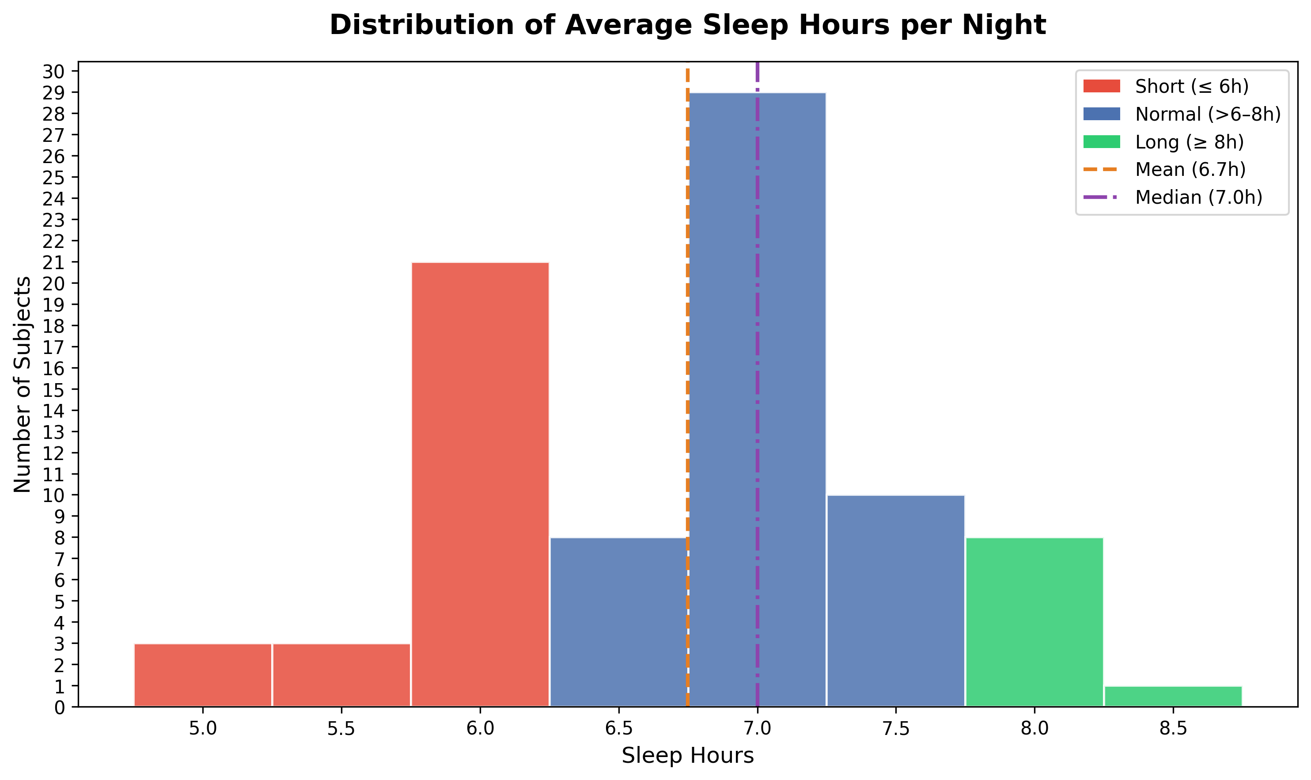
Figure 3.1 Distribution of average sleep hours per night across all 83 participants. Red bars indicate short sleepers (<= 6 h), blue bars indicate normal sleepers (>6 - 8 h), and green bars indicate long sleepers (>= 8 h).
The Emotiv EPOC is a consumer-grade wireless EEG headset used for the experiment. It has 14 saline-based electrodes positioned at AF3, F7, F3, FC5, T7, P7, O1, O2, P8, T8, FC6, F4, F8, and AF4. It records at a sampling rate of 128 Hz and outputs both raw EEG signals and pre-computed spectral features (FFT power values) alongside seven proprietary performance metrics. Each recording session produces a data.csv file containing timestamped EEG readings with inline task marker events, and a marker.csv file containing the task name mapping. The device also provides per-channel and overall signal quality indicators, as well as an interpolation flag marking reconstructed samples. These outputs form the basis of the analysis-ready dataset covering all 83 participants; how the raw recordings were filtered, segmented, and prepared for modelling is described in detail in Chapter 4.

Cognitive Tasks and Experimental Procedure
Each participant completed a structured protocol of approximately 60 cognitive tasks, designed to engage different functional brain regions. The tasks are organised into six functional domains, each targeting specific neural circuits:
Cognitive and Language tasks involve verbal processing, including word generation based on semantic categories, sentence construction, and reading aloud. These tasks primarily engage prefrontal and frontal brain regions (targeted electrodes: AF3, AF4, F7, F3, F4, F8) and produce characteristic broadband EEG activation, including elevated theta, beta, and gamma power due to combined cognitive effort and speech-related muscle artifact.
Memory tasks include word and number memorisation followed by recall phases. The memorisation phase is associated with frontal working memory circuits , while the recall phase tends to additionally recruit temporal and parietal regions [8]. Frontal theta is commonly elevated during memory encoding tasks of this type.
Visual and Spatial tasks encompass dot-following, 2D and 3D pattern recognition, and sequence completion exercises. These tasks are associated with parietal and occipital regions [8] involved in visuospatial processing and spatial reasoning.
Motor and Action tasks consist of left-hand and right-hand motor execution with eyes open and eyes closed, as well as motor coordination exercises. These tasks are generally expected to engage motor cortex regions and are consistent with lateralised changes in beta power commonly observed in motor-related desynchronisation research.
Auditory tasks involve listening to music clips and counting the number of instruments, as well as category based word generation triggered by auditory stimuli. These tasks are associated with temporal brain regions [8] , and alpha enhancement is commonly observed when participants close their eyes to concentrate on auditory input.
Emotional tasks present images designed to elicit happiness, sadness, and anger responses. These passive viewing tasks produce relatively suppressed EEG activation across all bands compared to active cognitive tasks, reflecting reduced active processing during emotional image observation.
The experimental protocol also includes baseline and calibration phases (eyes open, eyes closed, and a free-talking baseline), as well as instructional phases that precede each task block. These non-task phases are excluded from the analysis, retaining only the stimulus phases where participants are actively engaged in a cognitive task. Each task is identified by a unique integer marker value (MarkerIndex) embedded in the EEG data stream, and the marker-to-task name mapping is defined in a stimuli reference file. The MarkerIndex events are used to segment the continuous EEG recording into task level epochs, within which spectral features are averaged to produce one feature vector per task per participant.
The combination of multiple task types is important for this research because different cognitive demands induce different EEG patterns, and the relationship between EEG features and sleep duration may vary across task types. A key analysis question is which specific tasks or task domains produce EEG features that are most strongly associated with sleep duration, as this information guides both the interpretation of results and the selection of features for the predictive model.
Of the approximately 60 tasks in the full protocol, 36 active stimulus phases per participant were retained after excluding baseline, calibration, and instructional phases. Each stimulus phase lasts approximately 60 to 90 seconds, resulting in a total recording duration of roughly 45 to 60 minutes per participant. From the 36 retained tasks, the exploratory analysis in Chapter 5 identified five tasks as most consistently associated with sleep duration: gyrus_left_closed_eyes, gyrus_right_closed_eyes, gyrus_coord, prefrontal1, and prefrontal2. Three of these belong to the Motor and Action domain (closed-eyes gyrus tasks and coordination), and two target the prefrontal domain specifically. The closed-eyes condition in the motor tasks is particularly relevant because removing visual input isolates the neural response to motor preparation and execution, reducing the contribution of visual cortex activity and making frontal and central spectral patterns more interpretable. These five tasks form the restricted feature set used in experiments „exp3“ and „exp6“.

Signal Processing and Feature Extraction
This chapter describes the steps taken to transform raw EEG recordings into a clean, structured dataset suitable for machine learning. The pipeline covers signal quality filtering, task segmentation, and feature extraction, and was applied consistently across all 83 participants.

Signal Quality Filtering
Raw EEG recordings are often exposed to noise from electrode contact failure, head movement, and electrical interference. The Emotiv EPOC headset provides built-in quality indicators that were used to identify and remove unreliable data samples before any analysis was performed. Three filtering criteria were applied at the row level, meaning individual time samples were removed rather than entire participant recordings:
- EEG.Interpolated == 0: rows flagged by the Emotiv firmware as interpolated (reconstructed from neighbouring samples) were excluded, as they do not represent genuine neural measurements.
- CQ.Overall >= 0.7: the overall channel quality score, ranging from 0 to 1, reflects the aggregate contact quality across all electrodes. Only rows meeting the 70% threshold were retained.
- Per-channel CQ >= 2: each of the 14 individual channel quality scores (scale 0-4) was required to meet a minimum of 2 (fair contact) simultaneously. This ensures that no single electrode with poor contact contaminates the averaged feature values.
These filters were applied before task segmentation so that only clean samples contribute to the computed features. The strictness of the simultaneous per channel requirement means that some samples are removed even when most channels are good, but this conservative approach reduces the risk of noise-driven features entering the model. Even with that most of the participants retained the majority of their task segments after filtering. The filtered and segmented data were saved to a structured CSV file per participant, retaining only quality approved samples alongside task labels, all 70 FFT band power features, and Emotiv Performance Metric scores, forming the clean input dataset for all subsequent feature extraction and modelling steps.
Applying the filters at the row level rather than at the participant level is a deliberate design choice: it avoids discarding entire participants due to isolated signal problems in one or two tasks, which would reduce the already limited sample of 83 subjects. The resulting dataset contains 2,830 task-level observations across all 83 participants, corresponding to an average of 34.1 tasks per subject against the maximum of 36. This means fewer than 6% of potential task observations were lost to quality filtering, indicating that signal quality was generally high across the dataset. No participant was excluded entirely as a result of quality filtering; 76 out of 83 participants retained 30 or more clean task observations, with the remaining 7 retaining between 8 and 28 tasks. The two participants held out for the live demonstration at the defence (ba16 and ba45) were processed through the same filtering pipeline to ensure their feature vectors are directly comparable to those used during training.

Task Segmentation and Epoch Extraction
Each participant's data.csv file contains a continuous EEG recording spanning the entire experimental session. To analyse brain activity during specific cognitive tasks, the continuous recording must be segmented into task level epochs. This was achieved using the MarkerIndex column embedded directly in the EEG data stream by the Emotiv recording software. A positive MarkerIndex value indicates the start of a task event, and the corresponding negative value marks its end. This inline marker approach is independent of the separate marker.csv file and is robust to any variance in external files.
For each cognitive task, the corresponding start and end timestamps were extracted from the MarkerIndex events, and all quality-filtered EEG rows falling within that time window were grouped into a single epoch. Calibration phases, eye-open and eye-closed resting periods, and instructional phases were excluded, retaining only the 36 active stimulus phases per participant. This produced a structured dataset where each row represents one participant completing one task.

FFT Band Power Feature Extraction
The Emotiv EPOC software computes spectral band power features in real time using a Fast Fourier Transform applied to a sliding window of the raw EEG signal. These are stored in the POW columns of the data.csv file. Although the raw EEG is sampled at 128 Hz, the Emotiv firmware updates FFT power values at approximately 8 Hz: only roughly one in every 16 rows contains actual POW measurements, while the remaining rows hold NaN values in the POW columns. Feature averaging using pandas .mean() handles this correctly by skipping NaN values, so no rows need to be discarded before aggregation. Five frequency bands are provided for each of the 14 electrode channels, yielding 70 FFT features in total:
- Theta (4–8 Hz): associated with drowsiness, memory encoding, and relaxed attention.
- Alpha (8–12 Hz): associated with relaxed wakefulness; suppressed during active visual processing and engagement.
- Beta Low (12–16 Hz): associated with active thinking, focus, and motor control.
- Beta High (16–25 Hz): associated with high cognitive load, alertness, and stress.
- Gamma (25–45 Hz): associated with high-level cognitive binding, perception, and attention.
Notably, the Emotiv firmware does not output the Delta band (0.5-4 Hz); only Theta through Gamma are available. Because Delta/slow wave activity is the frequency range most directly tied to sleep homeostasis, the most sleep relevant part of the spectrum is inaccessible with this device.
Within each task epoch, the FFT band power values were averaged across all retained time samples to produce a single representative feature vector per participant per task. This aggregation reduces noise while preserving the characteristic spectral profile of each task. The resulting dataset contains 70 FFT features alongside seven Emotiv Performance Metric scores (Attention, Engagement, Excitement, Relaxation, Focus, Stress, Interest), participant sleep hours, and gender for each task observation.

Exploratory Data Analysis
Before developing a predictive model, an extensive exploratory data analysis (EDA) was conducted to characterise the EEG features, identify which signals are associated with sleep duration, and determine whether univariate approaches are sufficient or whether multivariate machine learning is necessary. The analyses progress from validating the EEG data quality, through examining feature sleep relationships at increasing levels of specificity, to identifying the tasks and channels most informative for sleep prediction. Prior to the main analysis, an exploratory pilot was conducted on 10 randomly selected subjects, producing individual level EEG spectral maps. The results showed high inter subject variability with no consistent pattern across individuals, confirming that population level aggregation rather than individual profiling is the appropriate approach for a dataset of this size, an observation that motivates the group level analyses presented in all subsequent sections.

Physiological Validity of EEG Data
The structured analysis begins with a physiological validity check, verifying that the EEG recordings reflect known neural patterns rather than noise or recording artefacts. A Z-score normalised heatmap of median band power per cognitive task was produced, where each band was normalised independently so that patterns across tasks could be compared on a common scale. Figure 5.1 presents this sanity check.
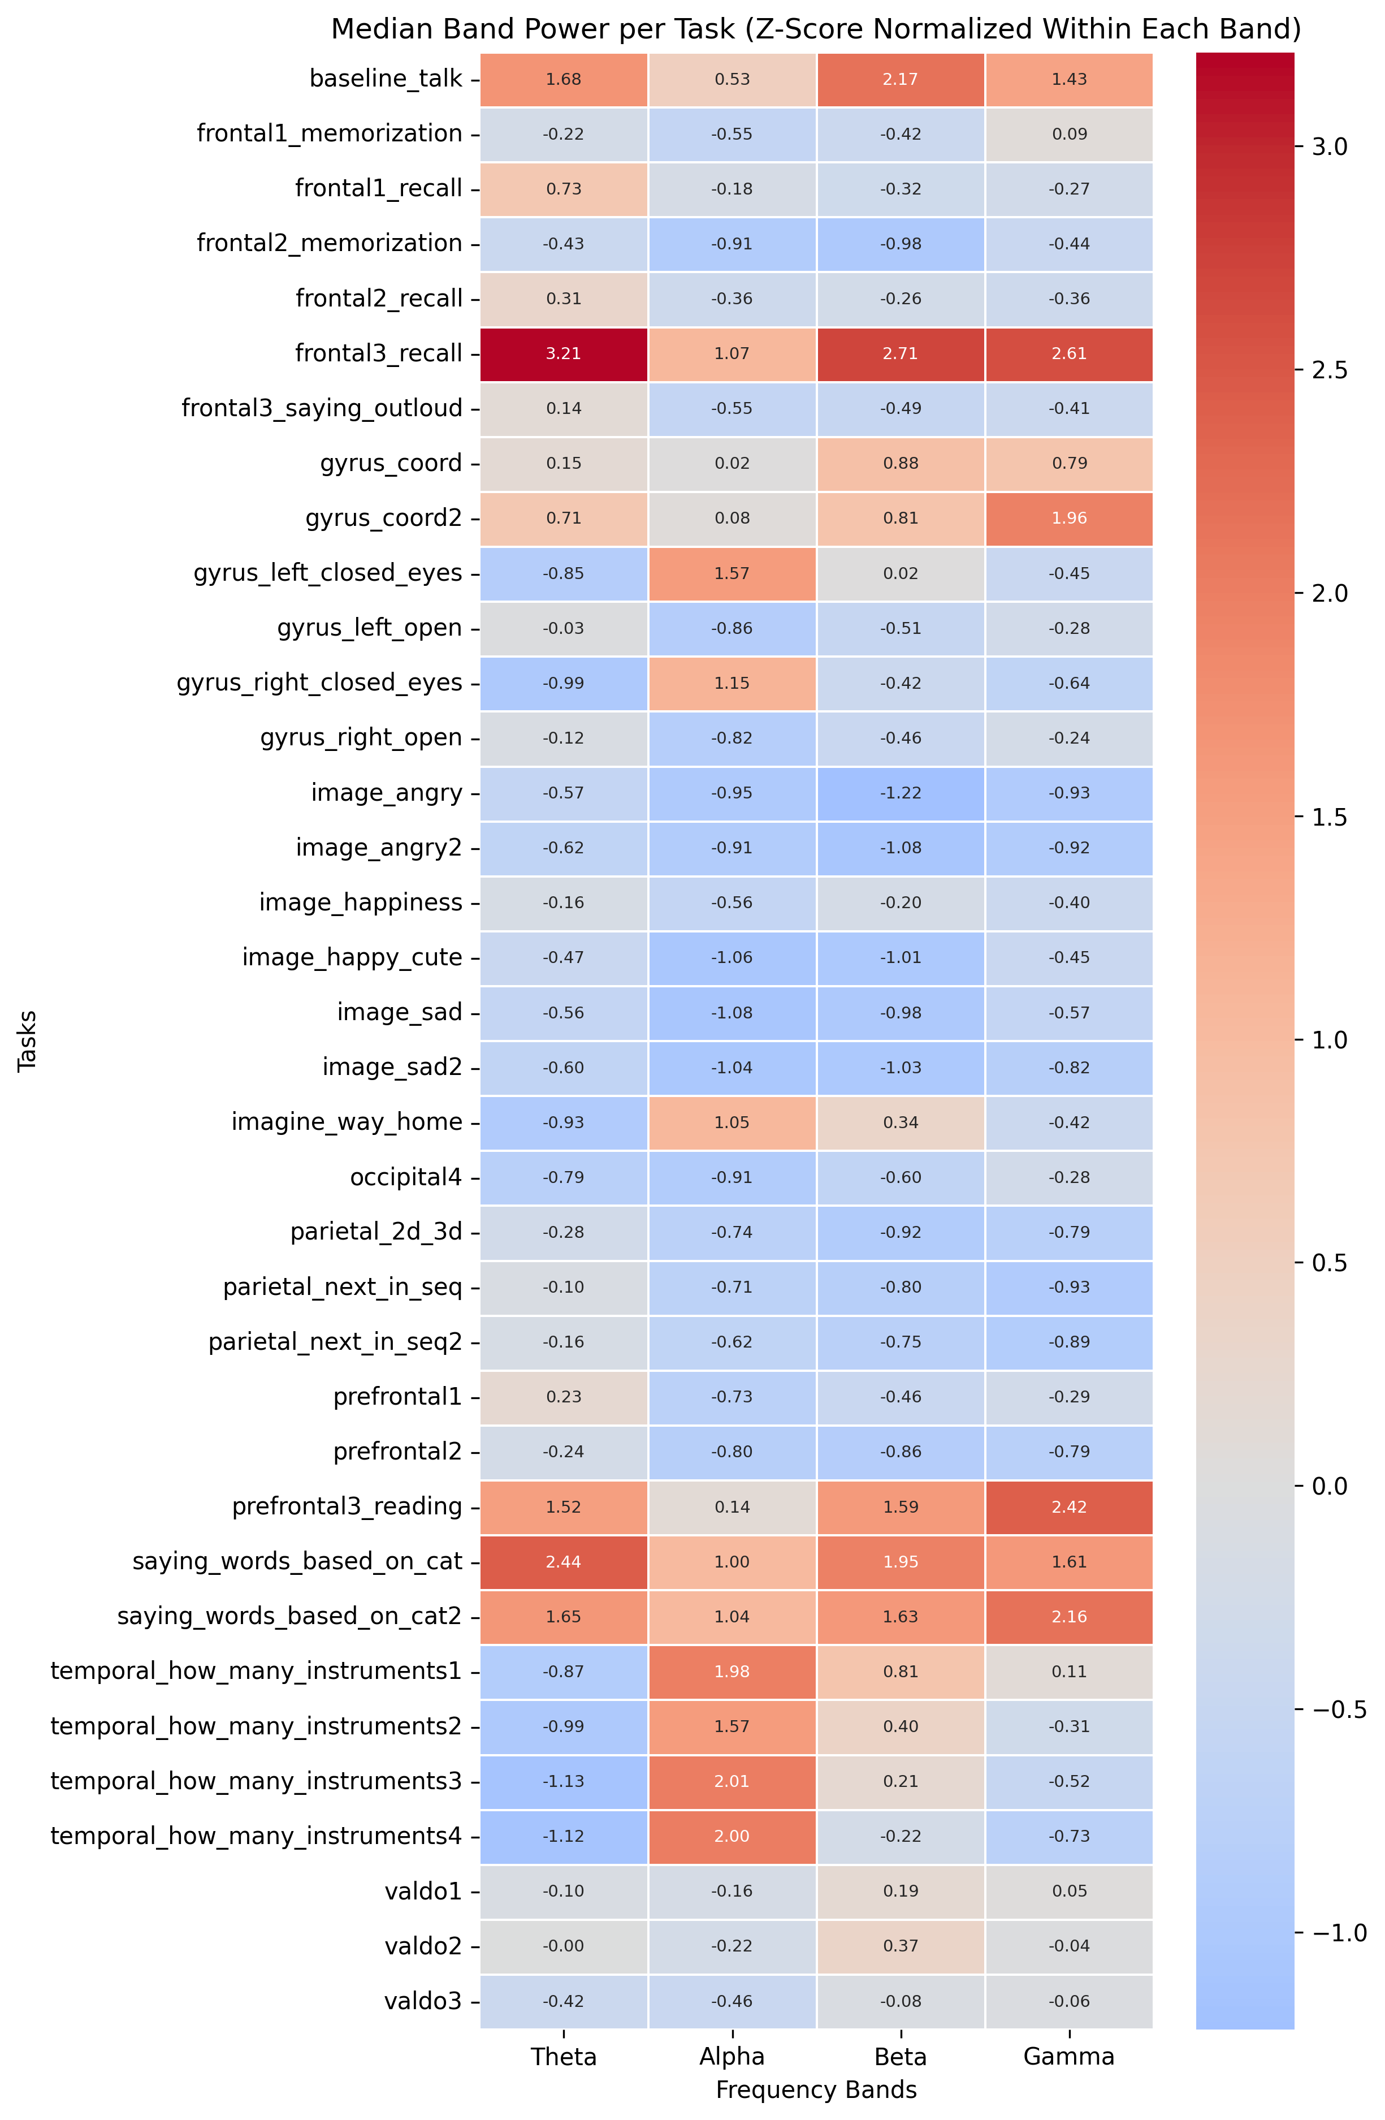
Figure 5.1. Median FFT band power (Z-score normalised within each band) across all 36 cognitive tasks. Red indicates above-average activation; blue indicates below-average. Patterns are consistent with established EEG neuroscience.
The heatmap confirms that the EEG recordings are physiologically valid; four consistent patterns are clearly visible.
First, speech based tasks such as baseline_talk, frontal3_saying_outloud, and saying_words_based_on_cat show broadband activation across Theta, Beta, and Gamma bands, consistent with electromyographic (EMG) contamination from jaw and facial muscle movement during vocalisation, a well documented phenomenon in EEG research [13].
Second, eyes-closed and mental imagery tasks such as imagine_way_home and the temporal instrument counting tasks show strong Alpha enhancement, reflecting the classic alpha blocking release when the visual cortex is not processing external input [12].
Third, passive image-viewing tasks (image_happiness, image_sad, image_angry) are uniformly suppressed across all bands, indicating reduced active neural processing compared to tasks requiring deliberate cognitive effort.
Fourth, the verbal recall task frontal3_recall shows pronounced Theta elevation alongside elevated Beta and Gamma activity, consistent with the established role of frontal Theta in active memory processing and cognitive load, where theta synchronises in hippocampo cortical circuits under increasing memory demands [12]. Unlike the speech related broadband pattern, this elevation is Theta dominant, reflecting genuine cognitive neural activity rather than muscular artefact.
These patterns collectively demonstrate that the EEG device captured meaningful neural signals and that data collection and preprocessing did not introduce systematic artefacts.

Task Category | Characteristic Signal | Neural Basis/Interpretation
Speech-based | Broadband Theta, Beta, Gamma | EMG contamination (jaw/facial muscle)
Eyes-closed | Strong Alpha enhancement | Alpha blocking release (no visual input)
Passive Viewing | Uniform suppression | Reduced active neural processing
Verbal Recall | Frontal Theta elevation | Active memory/cognitive load
Table 1. Summary of characteristic EEG task signatures

Relationship Between FFT Features and Sleep Duration
Having established the physiological validity of the EEG data, the next step was to examine which spectral features are associated with the target variable: average nightly sleep hours. To address the between subjects nature of the research question, Pearson correlations were computed at the subject level: for each participant, FFT features were first averaged across all tasks, and correlations were then computed across the 83 subjects. Pearson correlation is a statistical measure of the linear relationship between two continuous variables. The Pearson correlation coefficient (r) ranges from -1 to +1: +1 indicates a perfect positive linear relationship, 0 indicates no linear relationship, and -1 indicates a perfect negative linear relationship. Figure 5.2 shows the resulting correlation values for all 70 features.
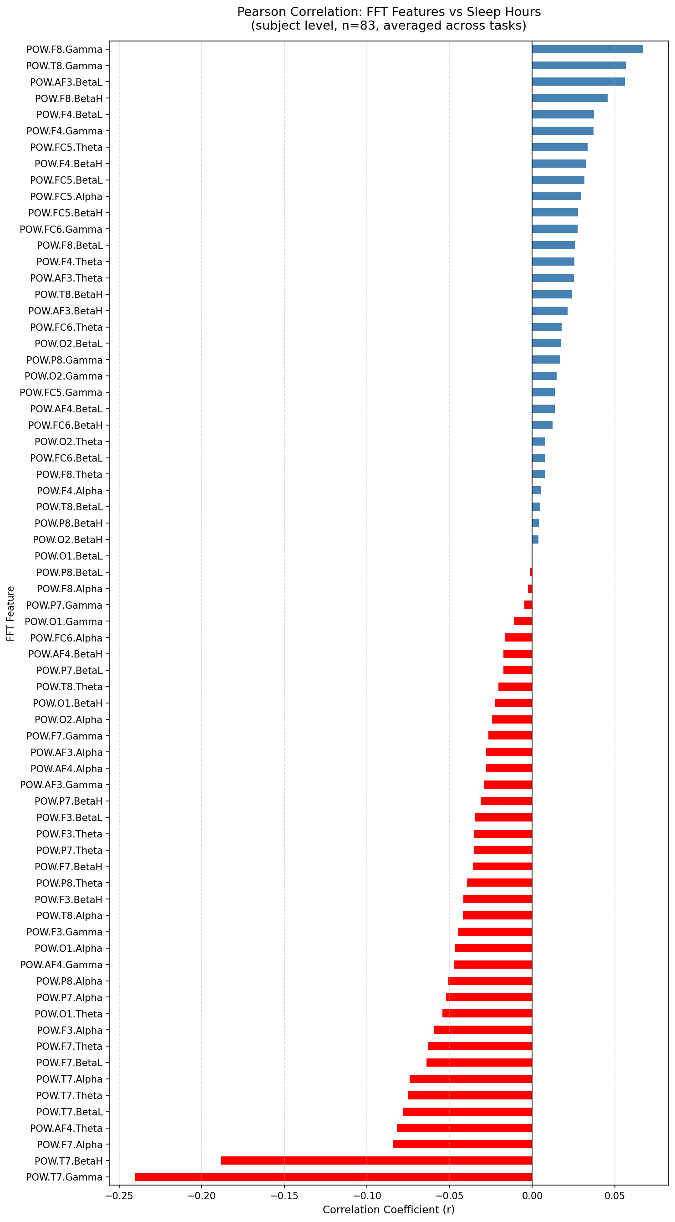
Figure 5.2. Pearson correlation between each FFT feature and Sleep_Hours at the subject level (n=83; features averaged across all tasks per participant). Blue bars indicate positive correlations; red bars indicate negative correlations. T7.Gamma is the only feature reaching nominal significance (r = −0.24, p = 0.029, uncorrected).

The dominant signal is a negative association at the left temporal electrode T7, T7.Gamma shows the strongest correlation (r = −0.24, p = 0.029) and T7.BetaH is also consistently negative (r = −0.19, p = 0.088). This indicates that participants who sleep fewer hours tend to show higher left temporal high-frequency power across cognitive tasks. In contrast, positive correlations are weak across all features, with no feature exceeding r = +0.07 and none approaching statistical significance. The elevated left temporal high frequency activity in shorter sleepers may reflect compensatory cortical hyperarousal, though a contribution from electromyographic artefact at the T7 electrode, which sits over the temporal muscle, cannot be ruled out with this dataset .
Figure 5.3 presents subject level scatter plots for the features showing the clearest association with sleep hours.
As a supplementary check, correlations were also computed at the row level across all 2,830 task observations. Since each person's sleep hours are the same across all their rows but their EEG varies widely between tasks, task to task variability dominates the correlation and dilutes the between person sleep signal. The directional pattern is consistent, T7.Gamma remains the strongest negative correlate, but the subject level analysis is the primary result throughout this chapter.
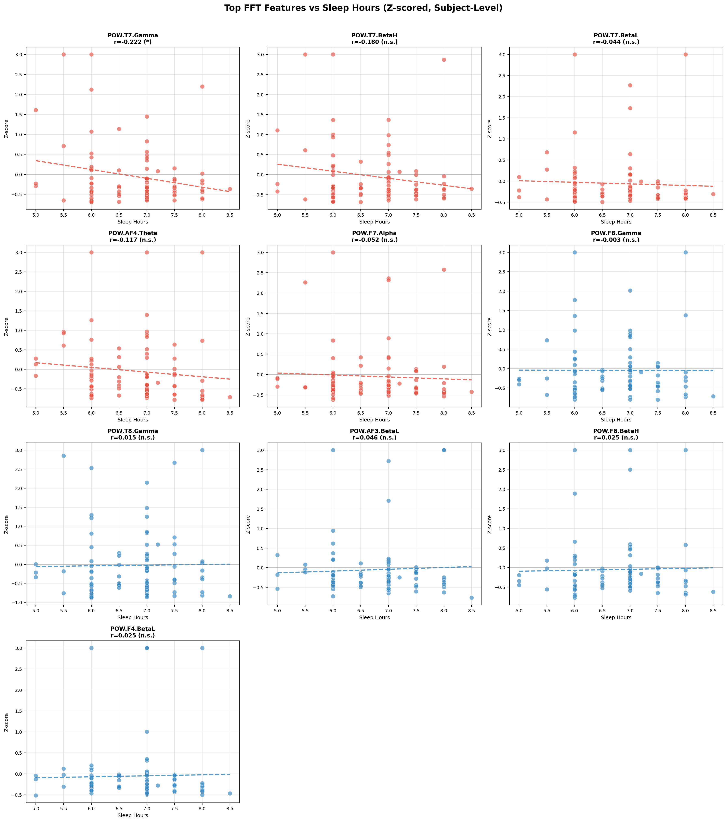
Figure 5.3. Subject level scatter plots: top 10 FFT features versus Sleep_Hours (n=83), selected from the subject-level correlation analysis. Features are Z-score normalised and outliers clipped at +/- 3 SD. Red = top negative correlates; blue = top positive correlates.

The scatter plots confirm the pattern from Figure 5.2. T7.Gamma shows the clearest negative trend (r = −0.22, p = 0.044, values differ slightly from Figure 5.2 due to z-score normalisation and outlier clipping applied before plotting) and T7.BetaH also displays a consistent negative slope (r = −0.18, p = 0.104), suggesting a broader left temporal high frequency signal rather than an isolated feature effect. All positive features are essentially flat, with correlations near zero.
These p-values are uncorrected for multiple comparisons: with 70 features tested, the Bonferroni-corrected threshold is p < 0.0007, under which no feature, including T7.Gamma, reaches significance. These results confirm that no single FFT feature can reliably predict sleep hours on its own, motivating the multivariate machine learning approach adopted in Chapters 6 and 7.

EEG Features and Emotiv Performance Metrics
In addition to FFT band power, the Emotiv EPOC provides seven proprietary Performance Metrics (PM): Attention, Engagement, Excitement, Relaxation, Focus, Stress, and Interest. These are computed internally by the Emotiv algorithm from the raw EEG signal. To understand their relationship with spectral features, Pearson correlations between FFT band power and each PM score were computed separately for frontal and parietal/occipital brain regions.
Figures 5.4 and 5.5 present the results. Because this analysis examines internal relationships between EEG derived signals, rather than predicting sleep duration, it was conducted on the 10 subject pilot group (n = 324 task observations), which provided a first characterisation of how the device's spectral and metric outputs co-vary.
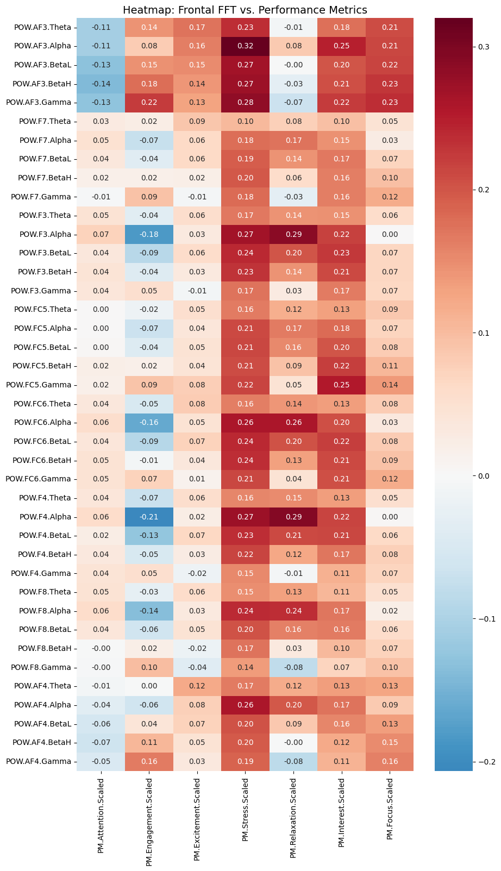
Figure 5.4. Pearson correlations between frontal FFT band power and Emotiv Performance Metrics. Values annotated in each cell.
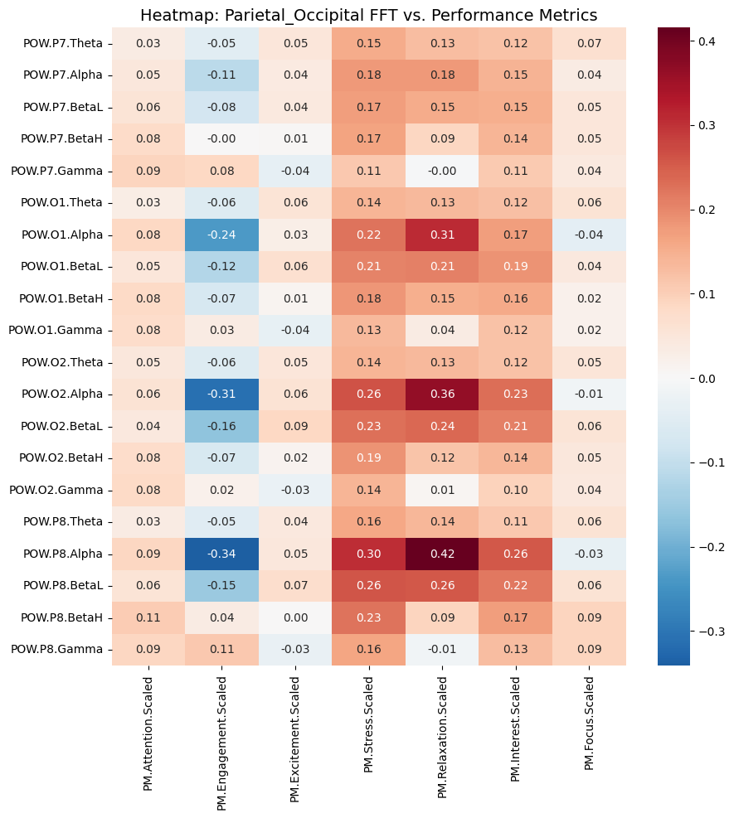
Figure 5.5. Pearson correlations between parietal and occipital FFT band power and Emotiv Performance Metrics.

Several interpretable patterns emerge. In the frontal region, Alpha power is negatively correlated with Engagement at lateral frontal and central electrodes (r ≈ −0.21 at F4.Alpha; −0.18 at F3.Alpha; −0.16 at FC6.Alpha), consistent with the well established alpha blocking effect: alpha is suppressed when a person is actively engaged with a task [12]. The prefrontal electrode AF3.Alpha shows a qualitatively different pattern,a near zero association with Engagement (r ≈ +0.08) but the strongest positive frontal correlation with Stress (r ≈ +0.32), followed by high frequency bands at the same site (BetaH r ≈ +0.27, Gamma r ≈ +0.28).
In the parietal and occipital region, the strongest associations are found at P8.Alpha: it correlates positively with Relaxation (r = +0.42) and negatively with Engagement (r = −0.34), together confirming the classic posterior alpha pattern, alpha rises during relaxed, internally directed states and is suppressed when the visual cortex is actively engaged with external stimuli [12].
A separate PM-PM correlation analysis reveals that several metrics that should be physiologically distinct are in fact strongly positively correlated with one another: Stress-Interest r = 0.75, and notably Stress-Relaxation r = 0.55, two metrics that would be expected to be inversely related. This suggests the seven PM scores are not independent physiological constructs but partly share a common signal from Emotiv's internal algorithm. Their individual correlations with Sleep_Hours are modest, with Engagement being the strongest positive correlate (r = +0.36) and Relaxation the strongest negative (r = -0.30); all remaining PMs fall below |0.22|. These metrics were not included in the predictive model for this thesis, as the modelling experiments focused exclusively on FFT band power features.

Sleep Group Comparisons
To directly test whether individuals in different sleep duration categories show measurably different EEG profiles, a group comparison analysis was conducted using Mann-Whitney U tests. A Mann-Whitney U test is a non-parametric statistical test used to determine if there is a difference between two independent groups (e.g., Short vs. Normal sleepers). It is used here to demonstrate that univariate thresholds are insufficient, which is the exact reason the research moved to a multivariate Random Forest model.
Ten FFT features were selected: the five strongest negative correlates (T7.Gamma, T7.BetaH, T7.BetaL, AF4.Theta, F7.Alpha) and five strongest positive correlates (F8.Gamma, T8.Gamma, AF3.BetaL, F8.BetaH, F4.BetaL) from the subject level correlation analysis. Two grouping strategies were evaluated: a three-way split (Short: less or equal then 6h, Normal: >6 - 8h, Long: more or equal to 8h) and a two-way split (less or equal to 7h vs more then 7h) at the sample median. Bonferroni correction was applied to account for multiple comparisons.
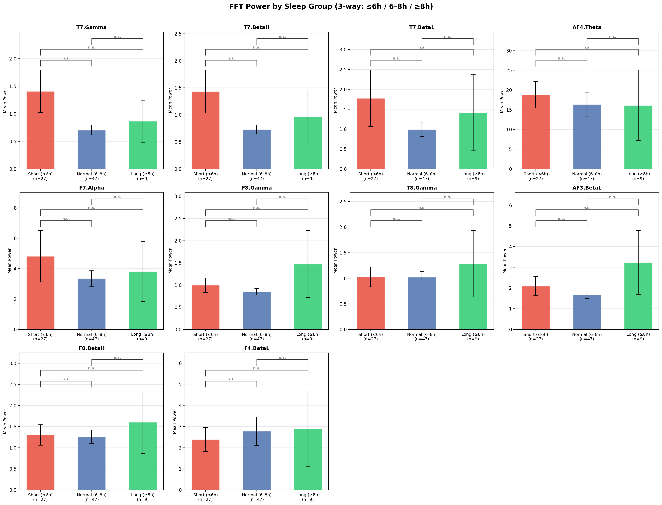
Figure 5.6. Mean FFT power across sleep groups (3-way split: Short n=27, Normal n=47, Long n=9). Error bars show SEM. Brackets indicate Bonferroni-corrected significance (α_corrected = 0.05/30 ≈ 0.0017). All comparisons non-significant after correction.
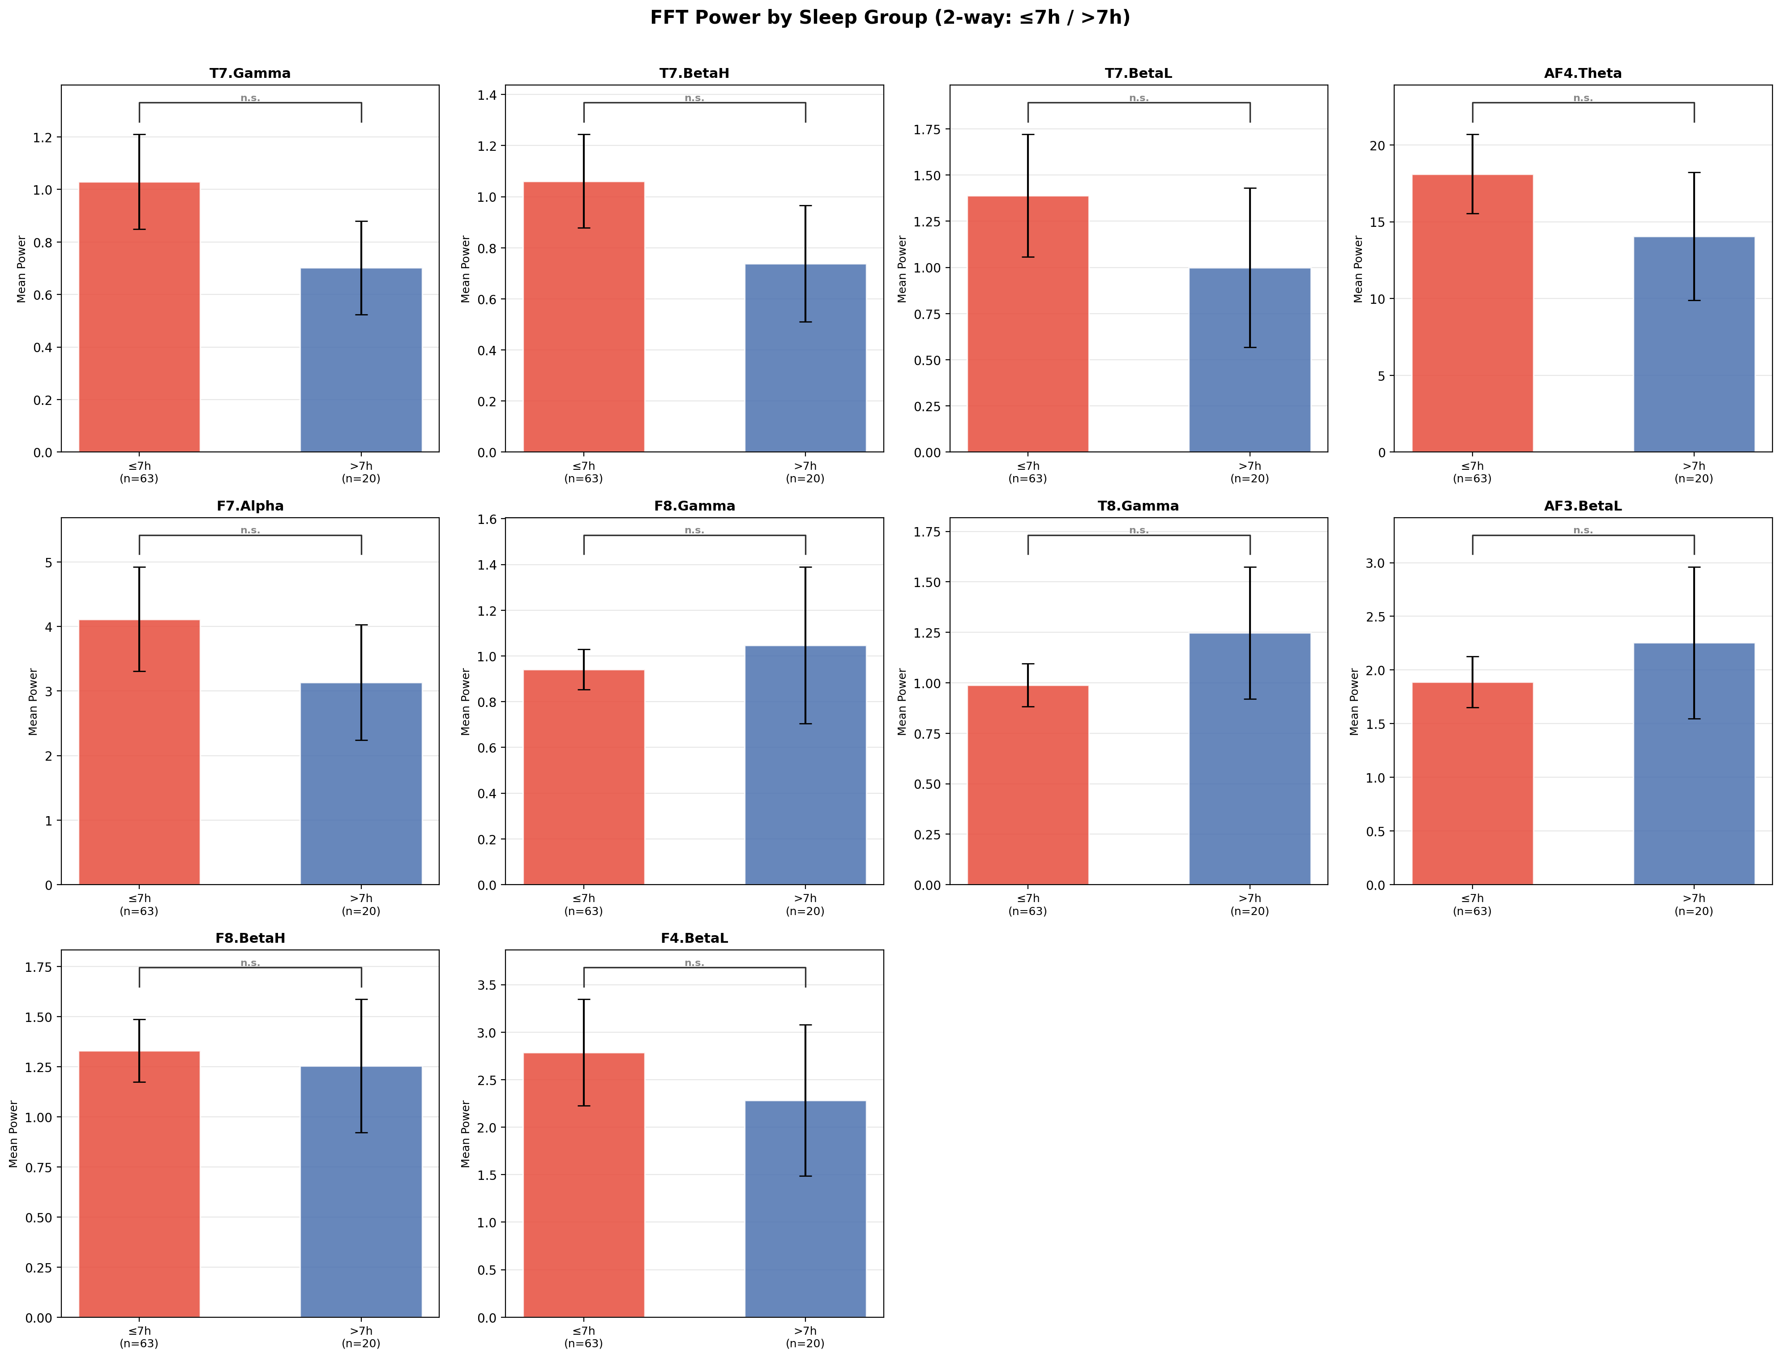
Figure 5.7. Mean FFT power across sleep groups (2-way split: ≤7h n=63, >7h n=20). All 10 comparisons non-significant (lowest p ≈ 0.10 for T7.BetaL and AF4.Theta).

No FFT feature significantly differentiates sleep groups in either the three-way or two-way analysis, not even at the uncorrected α = 0.05 threshold. The closest result in the three-way comparison is AF4.Theta (Short vs Long, p = 0.053), which falls just above the nominal threshold. The directional pattern is nonetheless consistent with the correlation analysis: T7 features show higher power in the Short group than Normal, and positive correlates (F8.Gamma, T8.Gamma) show higher power in the Long group, but the effect sizes are too small to reach significance at this sample size. The two-way split yields all comparisons above p = 0.10, confirming the absence of detectable univariate separation.
Sleep duration is narrowly distributed in the sample (std = 0.78 h, with the vast majority of participants sleeping between 6.0 and 7.5 hours), leaving very limited between-group variance for any single feature to exploit. Even the closest result (AF4.Theta, Short vs Long, p = 0.053) does not even reach nominal significance (α_corrected = 0.0017 for 30 pairwise tests). More fundamentally, sleep duration effects on daytime EEG are not expected to manifest in any single channel or band in isolation: they are distributed, multivariate signals. The group comparison analysis therefore serves a diagnostic function, and it confirms that the problem cannot be solved by simple univariate thresholds and therefore motivates the Random Forest approach described in Chapters 6 and 7.

Per-Task FFT–Sleep Correlation Analysis
The analyses in Sections 5.2 and 5.4 aggregate EEG features across all tasks per participant, treating the cognitive protocol as a single undifferentiated block. This approach does not capture the possibility that some tasks elicit EEG patterns more strongly linked to sleep than others. To investigate this, Pearson correlations were computed between subject-level mean FFT band power and Sleep_Hours separately for each of the 36 cognitive tasks. Figure 5.8 presents the results as a heatmap; It is worth noting that tasks appearing suppressed in Figure 5.1, showing below average absolute power, can still show strong between subject sleep correlations: suppression reflects the nature of the task condition, while sleep correlations capture individual differences within that condition.
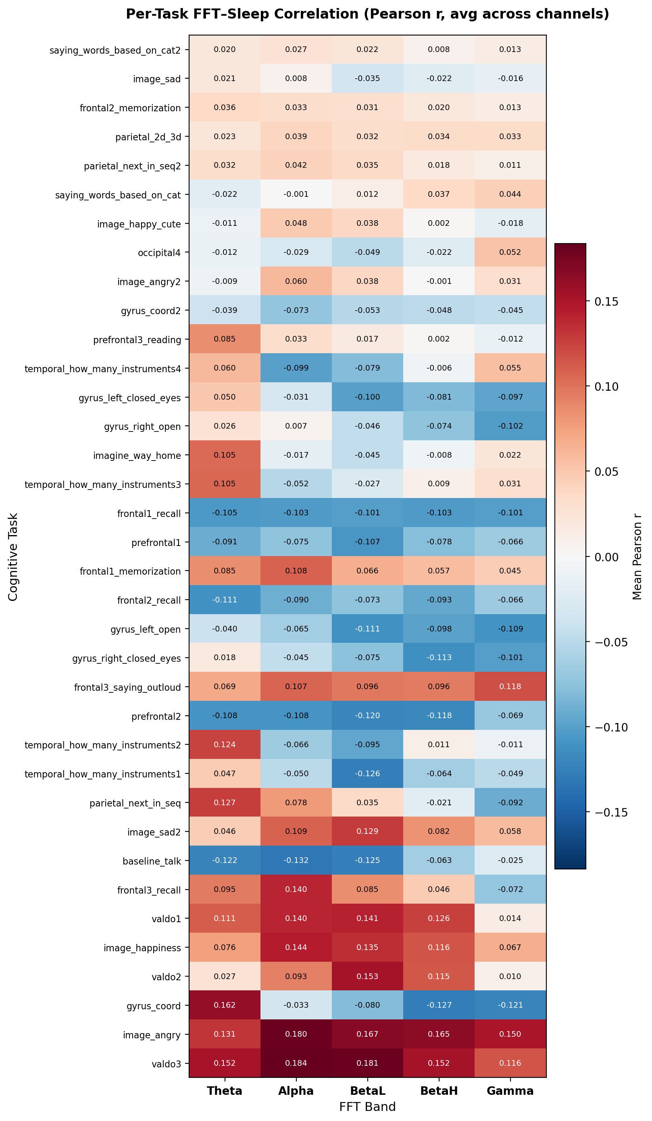
Figure 5.8. Per-task FFT- Sleep correlation heatmap (Pearson r, averaged across 14 channels per band). Tasks are sorted by maximum absolute r across bands. Most predictive tasks appear at the top; least predictive at the bottom.
Substantial variation in sleep predictive signal exists across tasks. The strongest positive correlations, where longer sleepers show higher EEG power, are observed during visual search tasks (valdo1, valdo2, valdo3: searching for an object within a complex scene) and emotional face perception tasks (image_angry, image_happiness), which show consistently elevated r values across all frequency bands (r ≈ 0.13–0.19). Gyrus_coord (bimanual motor coordination) shows a positive association restricted to Theta only.
In contrast, prefrontal arithmetic tasks (prefrontal1, prefrontal2) show negative correlations in high frequency bands, most notably prefrontal2.Gamma (r ≈ −0.39), suggesting that longer sleepers engage less high frequency frontal activity during silent calculation, possibly reflecting more efficient neural processing. Proprioceptive motor tasks with eyes closed (gyrus_left_closed_eyes, gyrus_right_closed_eyes) also show negative correlations. Auditory perception, memory encoding, verbal fluency, and pattern reasoning tasks cluster near zero across all bands.
Figure 5.9 isolates the ten strongest individual task band channel combinations. While visual search and emotional tasks show the most consistently elevated correlations when averaged across all channels in Figure 5.8, Figure 5.9 reveals that the strongest individual channel band peaks belong to motor and prefrontal tasks at the T7 electrode. These focused peaks carry more discriminative power for the predictive model than broadly distributed but weaker signals.
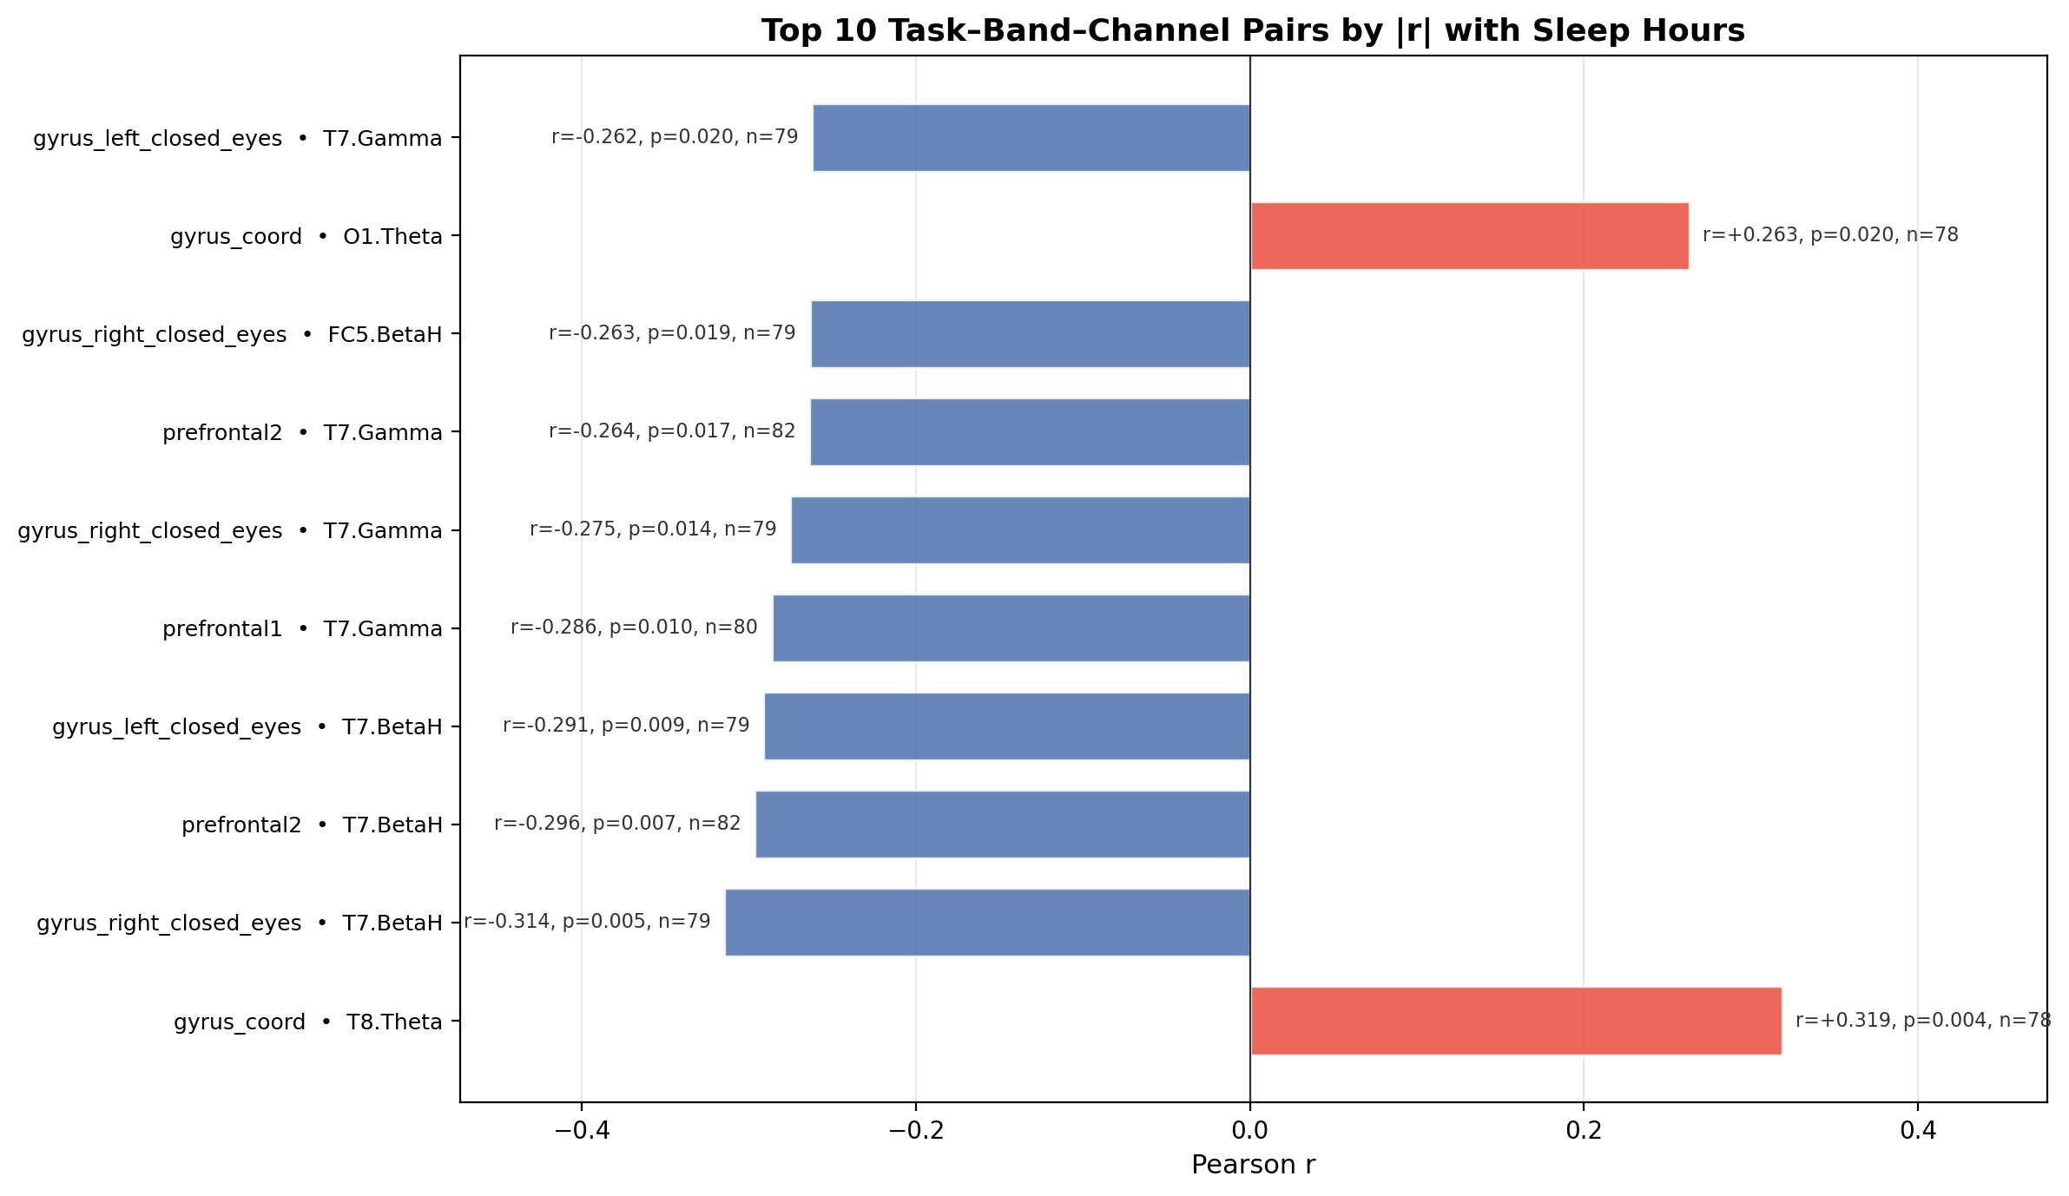
Figure 5.9. Top 10 task band-channel pairs by absolute Pearson r with Sleep_Hours (subject-level, n=78–83 per task). All ten pairs are nominally significant (p < 0.05, uncorrected for multiple comparisons). Blue = negative correlation; red = positive correlation.

All ten top pairs are nominally significant (p < 0.05, uncorrected), with several reaching p < 0.01. An important caveat applies: approximately 2,520 correlations were computed in total (36 tasks × 70 features), meaning roughly 126 false positives would be expected at α = 0.05 by chance alone. No single pair survives Bonferroni correction (threshold p < 0.00002). Uncorrected p-values are reported here because this analysis is explicitly exploratory, its purpose is to identify candidate features for the predictive model, not to make confirmatory claims, and because Bonferroni correction assumes independent tests, which is unrealistic given that features within the same channel and adjacent bands are highly correlated. The strongest evidence for a genuine signal is therefore not any individual p-value but the convergent pattern of the T7 electrode appearing across seven independent tasks and bands, a consistency that would be unlikely to arise from random noise. Three task types dominate the top results.
First, motor tasks performed with eyes closed (gyrus_left_closed_eyes, gyrus_right_closed_eyes) show strong negative correlations with Sleep_Hours, particularly in the T7 channel BetaH and Gamma bands (r ≈ −0.26 to −0.31). This finding is biologically plausible: motor tasks place demands on sustained attention and arousal, both of which are sensitive to sleep state [8], so EEG signatures recorded during motor execution may reflect underlying sleep related variation in neural efficiency."
Second, prefrontal working memory tasks (prefrontal1, prefrontal2) show significant negative correlations in T7 BetaH and Gamma (r ≈ −0.26 to −0.30), consistent with the well established sensitivity of prefrontal function to sleep loss.
Third, motor coordination tasks (gyrus_coord) show positive correlations in T8.Theta and O1.Theta (r ≈ +0.26 to +0.32), suggesting that better rested participants exhibit more occipital Theta during coordination tasks, potentially reflecting a more efficient, relaxed motor state.
The convergent T7 electrode pattern across tasks strengthens confidence that this finding reflects a genuine neural signal rather than noise, even in the context of the large number of correlations computed (~2,520 in total). These results directly identify the tasks and channels most informative for sleep prediction, providing principled guidance for feature prioritisation in the Random Forest model presented in Chapter 7. Building on these findings, a per-task prediction analysis (reported in Chapter 7) confirms that models trained on these five tasks yield the highest classification performance and additionally reveal interpretable subgroup patterns, for example, distinguishing two subgroups of short sleepers based on whether their daytime EEG signatures visibly reflect sleep pressure or show individual resilience.

Summary of Exploratory Findings:
Taken together, the five sections of this exploratory analysis tell a coherent story about the relationship between daytime EEG and habitual sleep duration.
First, the physiological validity check confirmed that the EEG recordings reflect genuine neural activity: known patterns such as alpha suppression during active tasks and alpha enhancement during eyes-closed conditions are clearly visible in the data. While the device demonstrates clear sensitivity to high magnitude transient states, such as the shift between active and idle brain activity, detecting low magnitude stable trait differences like habitual sleep duration represents a fundamentally harder problem. State effects are universal and large; trait effects are individual and subtle, and may approach the noise floor of consumer grade EEG hardware.
Second, the subject-level correlation analysis (one averaged value per participant, n = 83) identified T7.Gamma as the strongest correlate of sleep duration (r = −0.241, p = 0.029): longer sleepers show lower left temporal high frequency power. A supplementary row level analysis confirms the directional consistency but is treated as secondary due to repeated-measures inflation.
Third, the Emotiv Performance Metrics show interpretable links to FFT power (e.g., posterior Alpha strongly correlates with Relaxation), validating the metrics but also revealing their high inter-correlation, which limits their independent predictive value. Fourth, univariate sleep group comparisons yield no statistically significant differences after Bonferroni correction, confirming that no single EEG feature is sufficient on its own, a finding driven by the narrow sleep distribution in this sample and the distributed nature of sleep related EEG changes.
Fifth and most importantly, the per task correlation analysis identified five tasks (gyrus_left_closed_eyes, gyrus_right_closed_eyes, gyrus_coord, prefrontal1, prefrontal2) and one electrode location (T7, left temporal) as consistently the most informative across multiple independent analyses.
These findings directly motivate the modelling strategy described in Chapter 7: a Random Forest model trained on the top 5 tasks and top 15 features, evaluated using both GroupKFold (generalisation) and StratifiedKFold (per task interpretation).
Statistical Term | Definition
Pearson Correlation (r) | A measure of the linear relationship between two variables, ranging from -1 to +1.
p-value (p) | The probability that an observed result occurred by random chance; p < 0.05 is typically significant.
Standard Deviation (SD) | A measure of the amount of variation or dispersion in a set of values.
Alpha (α) | The significance threshold (e.g., 0.05) chosen to reject a null hypothesis.
Mann-Whitney U | A non-parametric test to compare differences between two independent groups.
Table 2. Summary of Statistical terms

Machine Learning Methods for EEG Data
This chapter provides the theoretical foundation for the machine learning methods applied in this thesis. It covers the Random Forest algorithm used for both regression and classification tasks, the cross validation strategies employed for model evaluation, the performance metrics used to quantify results, and the baseline comparisons against which model performance is interpreted. No experimental results are presented here, those are reported in Chapter 7.

The Random Forest Algorithm
Random Forest is an ensemble learning method introduced by Breiman [1] that constructs a large number of decision trees and aggregates their predictions. The underlying building block is the decision tree, which partitions the feature space through recursive binary splits: at each node, a feature and a threshold are selected to minimise an impurity criterion, Gini impurity for classification tasks or variance reduction for regression. While a single deep tree is prone to overfitting, combining many trees into an ensemble reduces this risk substantially [9].
The ensemble is built using two sources of randomisation. First, each tree is trained on a bootstrap sample, a random sample drawn with replacement from the training data, typically of the same size as the original dataset. Because each bootstrap sample excludes on average approximately one third of the training instances, different trees learn from different subsets of the data. This process, known as bagging (bootstrap aggregation), reduces variance without meaningfully increasing bias. Second, at each split node, only a randomly selected subset of features is considered as split candidates, typically the square root of p features for classification and p/3 for regression, where p is the total number of features. This feature subsampling decorrelates the individual trees so that the ensemble captures diverse patterns in the data rather than repeatedly focusing on the same dominant features [1].
The final prediction is the majority vote across all trees for classification, or their mean for regression. The number of trees (n_estimators) is a key hyperparameter: more trees reduce variance but increase computational cost. In this thesis n_estimators = 500 was used, which provides stable estimates for a dataset of this size. Random Forest is well suited to the EEG feature space used here: it handles the 70 dimensional FFT input effectively, is robust to noisy and redundant features, makes no assumptions about linearity or feature distributions, and naturally provides a measure of feature importance [5].
An additional configuration relevant to this thesis is class_weight = 'balanced' for classification tasks. The sleep category distribution is imbalanced, 27 Short, 46 Normal, and 8 Long sleepers, and without correction the model would be incentivised to predict the majority class. The balanced setting adjusts each class weight inversely proportional to its frequency (weight_c = n_samples / (n_classes x n_c)), ensuring that minority classes contribute equally to the training objective [5].
Random Forest provides a built in measure of feature relevance through mean decrease in impurity (MDI), also known as Gini importance. For each feature, the total weighted reduction in the impurity criterion across all split nodes and all trees where that feature was selected is accumulated and normalised to sum to one [1]. Features that produce larger and more consistent reductions in impurity receive higher importance scores. In this thesis, MDI based importance scores are used to rank the 70 FFT features and select the top 15 most informative ones for the final models, ensuring that the classifier is not diluted by uninformative channels or frequency bands.

Cross-Validation Strategy
With only 81 subjects available for modelling, a fixed train test split would leave too few observations in either partition for stable evaluation. Cross validation addresses this by rotating which portion of the data is held out for testing across k folds, ensuring that every observation contributes to the test set exactly once [10]. This thesis employs two distinct cross validation strategies that differ in how they assign observations to folds and consequently in what they measure.
GroupKFold assigns all rows belonging to the same subject to the same fold. In each iteration, the model is trained on data from a distinct subset of subjects and evaluated on a completely held out group of subjects it has never encountered during training. This prevents subject level leakage: the model cannot exploit the fact that different cognitive tasks from the same person tend to produce similar EEG patterns, a phenomenon sometimes described as the subject fingerprint effect. GroupKFold therefore provides an honest estimate of between subject generalisation, which is the operationally relevant question for a sleep monitoring system intended to work on new individuals. The results obtained under this strategy are reported as the primary, conservative evaluation in Chapter 7.
StratifiedKFold assigns individual task level observations to folds while preserving the class proportion in each fold, but imposes no subject constraint. This means the same subject's rows can appear in both training and test sets across different folds. On multi-row-per-subject datasets, where each subject contributes between 5 and 34 task level rows depending on the experiment, this allows the model to encounter a subject's EEG fingerprint during training and effectively recognise it at test time. This causes performance metrics to be substantially inflated relative to GroupKFold results. This strategy was applied specifically to enable per task interpretation: by examining which tasks the model consistently predicts correctly or misclassifies within the dataset, the most sleep informative tasks can be systematically identified. The inflated nature of these metrics is acknowledged and both sets of results are reported side by side in Chapter 7.[10]

Evaluation Metrics
Model performance is assessed using separate metrics for the regression and classification formulations of the problem.
For regression, three metrics are reported. The coefficient of determination (R²) measures the proportion of variance in sleep hours explained by the model, where R² = 1.0 indicates perfect prediction, R² = 0.0 is equivalent to always predicting the training mean, and negative values indicate performance worse than this trivial baseline. R² is used as the primary regression metric because it directly expresses predictive value relative to a mean baseline, making results interpretable regardless of the scale of the target variable.
Root Mean Squared Error (RMSE) expresses prediction error in the same units as the target variable, hours of sleep, and penalises large errors more heavily than small ones due to the squared term. Mean Absolute Error (MAE) provides the average absolute deviation in hours, offering a more directly interpretable measure of typical prediction error.[5]
For classification, two metrics are reported. Accuracy, the proportion of correctly classified subjects, provides an intuitive summary measure but is misleading when class sizes are unequal: a model that always predicts Normal would achieve 46/81 = 57% accuracy without learning anything meaningful. F1 macro addresses this limitation by computing the F1 score (the harmonic mean of precision and recall) independently for each class and averaging the results without weighting by class size [11]. This ensures that the Short (n = 27) and Long (n = 8) minority classes contribute equally to the final score, penalising models that ignore them in favour of the majority class.

Baseline Comparisons
All model results are interpreted relative to two naive baselines that represent the minimum acceptable level of performance. For regression, the mean baseline predicts the training set mean sleep duration for every test observation. This is the simplest possible model: it ignores all EEG features and outputs the average of the training labels. R² is defined such that R² = 0 corresponds exactly to this strategy, meaning a positive R² directly quantifies how much predictive value the EEG features add beyond this trivial baseline, while any negative value indicates performance worse than always predicting the mean.
For classification, the majority class baseline predicts Normal, the most frequent category, for every observation. In the 81 subject dataset, 46 participants fall into the Normal category, giving this baseline an accuracy of 56.8%. Any classifier that fails to exceed this threshold has not learned a useful relationship between EEG features and sleep duration; it has merely replicated the class distribution.
For the binary setting (Below7h vs Above7h, 35 vs 46 subjects), the majority class baseline is identical at 56.8%, making it a consistent reference point across both classification schemes. Reporting results relative to explicit baselines is standard practice in machine learning and guards against overinterpreting modest absolute performance figures [10].

Development and Evaluation of the Machine Learning Model

Pipeline Architecture and Implementation
The predictive modelling pipeline was implemented as a modular Python system operating across four stages: data preparation, modelling table construction, cross validation, and results export. Each stage is handled by a dedicated script, allowing individual components to be rerun independently when parameters change without reprocessing the entire dataset.
The pipeline begins with the raw Emotiv EPOC recordings stored per subject in the all_data/ directory. Each subject’s CSV file contains timestamped rows of 70 FFT power features (14 channels x 5 frequency bands: Theta, Alpha, BetaL, BetaH, Gamma) alongside a Task column identifying the cognitive task being performed. As described in Chapter 4, FFT power values are output at approximately 8 Hz rather than the raw 128 Hz sampling rate, so all feature aggregation uses pandas mean() to correctly handle the sparse NaN structure. The two preprocessing steps described in Chapter 4, CQ-based signal quality filtering (CQ.Overall ≥ 0.7, all channel scores ≥ 2) and task epoch extraction via inline MarkerIndex markers, were applied identically across all six experiments.
Two scripts build the modelling tables used as input to the cross-validation experiments. The script modelling_tables.py produces subject level tables (exp1- exp3) in which all rows belonging to a given subject are averaged to a single feature vector; optionally restricted to the top 5 tasks identified in the exploratory analysis. The script create_task_level_tables.py produces task-level tables (exp4 - exp6) in which each subject task combination is retained as a separate row. Exp4 yields approximately 34 rows per subject (all tasks); exp6 restricts to the top 5 tasks, yielding approximately 5 rows per subject. A windowed variant (exp5) further subdivides each task into 256 row windows of approximately two seconds each, yielding around 32,000 rows in total.
Cross validation is handled by two scripts. run_cv.py operates on subject level tables and applies standard KFold (equivalent to GroupKFold when each subject contributes exactly one row). run_task_cv.py operates on task level and windowed tables and supports both GroupKFold (subjects never split across folds) and StratifiedKFold (stratified by sleep category). Both scripts run a RandomForestRegressor and a RandomForestClassifier in parallel, using n_estimators = 500, max_features = ‘sqrt’, class_weight = ‘balanced’, and random_state = 42 throughout, ensuring reproducibility. Feature selection is performed at the start of each experiment by ranking all 70 features using MDI importance from a separate RandomForestRegressor fitted on the full dataset, then retaining the top N features specified for that experiment.
Results are written to per experiment subdirectories under results/, containing regression metrics (R², RMSE, MAE), classification metrics (accuracy, F1 macro, confusion matrix), scatter plots, and prediction CSVs.
A supplementary script analyse_task_predictions.py re runs the StratifiedKFold experiment on exp6 while retaining the Task column, enabling per task and per subject interpretation plots. A separate feature_importance_analysis.py script aggregates MDI scores by channel and frequency band and produces ranked bar charts and a channel-band heatmap. Finally, a permutation_test.py script validates whether the GroupKFold results are genuinely above chance by running 1,000 label shuffled repetitions of the same CV pipeline.
Three engineering decisions in the pipeline deserve explicit justification, as each has a non obvious rationale.
Decision 1: NaN-safe aggregation. As noted above, only roughly 1 in 16 rows contains valid power data; the rest are NaN. The correct aggregation call is therefore:
# Group by subject and task; NaN rows skipped automatically by .mean()
task_means = df.groupby([‘Subject_ID’, ‘Task’])[feature_cols].mean()
Decision 2: GroupKFold for honest cross-validation. With multiple rows per subject in task level tables, standard KFold assigns some rows of the same subject to training and others to test. GroupKFold prevents this by using Subject_ID as a grouping key so that whole subjects are separated across folds:
gkf = GroupKFold(n_splits=5)
for train_idx, test_idx in gkf.split(X, y_cat, groups=subject_ids):
# Every row for a given subject_id is in either train_idx or test_idx, never both

Decision 3: MDI-based feature selection outside the CV loop. With 70 features and only 81 subjects, including all features risks diluting the classifier with uninformative channels. A separate RandomForestRegressor is fitted once on the full dataset to rank all 70 features by MDI importance; the top-N are then passed to the CV loop. Running selection outside the loop is a deliberate tradeoff: it introduces minor optimistic bias but is computationally necessary when N_PERMUTATIONS = 1000 in the validation step.
selector = RandomForestRegressor(n_estimators=500, random_state=42)
selector.fit(X_all, y_hours) # rank on full data; same subset used in all folds
top_idx = np.argsort(selector.feature_importances_)[::-1][:TOP_N]

Experiment Design
The experimental design evolved through three phases, each addressing a limitation identified in the previous phase. Table 7.1 summarises all six experiments.
Phase 1: Subject level models with fixed thresholds (exp1, exp2, exp3). The first phase established a baseline using one aggregated row per subject. All tasks were averaged into a single feature vector (exp1, exp2), then restricted to the top 5 tasks identified in the exploratory analysis (exp3). Conventional sleep thresholds were used: Short <=6h, Normal >6-8h, Long =>8h. This produced a 27 / 46 / 8 class distribution. KFold cross validation at the subject level is honest by construction, one row per subject means leakage is impossible. Results (R² ≈ 0.05, F1macro = 0.39 for exp3) established the honest generalisation ceiling for subject level modelling.
Phase 2: Task level models with fixed thresholds (exp4, exp5, exp6). The second phase retained individual task rows to increase training data and enable per task interpretation. Exp4 produced one row per subject task pair (~2,760 rows); exp5 subdivided tasks into two second windows (~32,360 rows); exp6 restricted to the top 5 tasks (~390 rows). GroupKFold was applied for honest evaluation and StratifiedKFold for per-task interpretation, with fixed thresholds throughout. GroupKFold exp6 (R² = 0.095, F1 macro = 0.38) improved on the subject level baseline. For exp4 and exp5, where each subject contributes approximately 34 and several hundred rows respectively, StratifiedKFold reached R² = 0.65 and 0.67, exposing the subject leakage effect. Exp6 StratifiedKFold was lower (R² = 0.39), as restricting to five tasks per subject reduces the within subject rows available for the model to exploit. Across all fixed-threshold experiments the Long class (n = 8) remained nearly undetectable.
Phase 3: Task-level models with tertile thresholds (exp4 tertile, exp6 tertile). Fixed thresholds produced a severe class imbalance: 8 Long subjects cannot populate test folds reliably. The third phase replaced fixed boundaries with data driven tertile thresholds, cutting at the 33rd and 67th percentiles (<=6.5h / >6.5- 7h / >7h), yielding a 27 / 35 / 19 distribution. The tradeoff is that tertile boundaries lack clinical grounding: a subject sleeping 7.5 h becomes “Long” rather than “Normal”. Both threshold schemes are therefore reported in parallel: fixed thresholds as the clinically interpretable primary result, tertile thresholds as the statistically balanced variant. The tertile runs confirmed that the Long class’s apparent invisibility in Phase 2 was driven by sample size, not by absence of an EEG signal: in the StratifiedKFold task interpretation, Long recall rose from ≈37.5% (3/8 subjects) to 63.2% (12/20 subjects) once the class had sufficient representation.
Table 7.1. Summary of modelling experiments.
Exp | Description | Rows | Features | CV strategy | Tasks / scope
exp1 | All 36 tasks averaged per subject | 81. | 70 | GroupKFold (subject-level) | All 36 tasks
exp3 | Top-5 tasks averaged per subject | 81 | 15 | GroupKFold (subject-level) | Top-5 tasks only
exp4 | 1 row per subject–task (all tasks) | ~2,758 | 70 | StratifiedKFold (task-level) | All 36 tasks
exp5 | 256-row windows (~2 s) per task | ~32,360 | 70 | StratifiedKFold (window-level) | All 36 tasks
exp6 | 1 row per subject–task (top-5 tasks) | ~405 | 15 | GroupKFold and StratifiedKFold | Top-5 tasks only

Evaluation Results

GroupKFold Results (Honest Generalisation)
GroupKFold ensures that all recordings from a given subject are assigned entirely to either the training or the test set in each fold. This prevents the model from memorising individual EEG fingerprints and provides an honest estimate of generalisation to previously unseen individuals. Table 7.2 summarises the GroupKFold results.
Table 7.2. GroupKFold results across experiments (fixed thresholds, 5-fold).
Experiment | R² | Accuracy | F1 macro | RMSE (h) | Notes
exp1 (GroupKFold) | −0.12 | 49% | 0.24 | 0.81 | Predicts Normal for almost all subjects
exp3 (GroupKFold) | 0.05 | 60% | 0.39 | 0.74 | Top 5 tasks + top 15 features
exp6 (GroupKFold) | 0.095 | 60% | 0.38 | 0.73 | Top 5 tasks + top 15 features; Long recall = 0
Restricting the model to the top 5 tasks and top 15 features (exp3, exp6) improves both regression and classification compared to using all tasks (exp1), confirming that the task selection identified in Chapter 5 adds genuine predictive value. The exp6 GroupKFold result (R² = 0.095, F1 = 0.38) represents the strongest regression performance under honest evaluation in this study. One systematic weakness is visible across all GroupKFold experiments: the Long sleeper class (n = 8 under fixed thresholds) is almost never correctly predicted. With only eight subjects representing the Long category, most folds contain fewer than two Long subjects in the test set, making reliable learning impossible. Placing these results in context, the majority class baseline (always predicting Normal) achieves 57% accuracy on the 81-subject dataset. Notably, exp1 falls below this floor at 49% accuracy with all 70 features and all tasks, the model performs worse than constant prediction. The GroupKFold exp3 result of 60% and exp6 result of 60% both exceed the baseline, confirming that task and feature selection are necessary rather than optional.
The progression from exp1 to exp3 quantifies the value of task selection: F1 macro rises from 0.24 to 0.39 and R² moves from −0.12 to +0.05, meaning the model shifts from being actively worse than the mean baseline to extracting marginal but genuine signal. The further improvement in exp6, achieved by moving to the task level table with GroupKFold, shows that retaining individual task rows rather than collapsing everything into one subject level average gives the model more structure to work with, even under honest cross validation. The accuracy figures for exp3 (60%) and exp6 (60%) appear modest, but they are consistent across folds and confirmed as above chance by the permutation test described in Section 7.6. The RMSE values across experiments remain within 0.7 – 0.85 hours, indicating that the regression model’s predictions are typically within one hour of the true sleep duration.

StratifiedKFold Results and the Leakage Effect
StratifiedKFold was also applied to the task level and windowed tables (exp4, exp5, exp6), and unlike GroupKFold it does not group by subject: it splits individual rows while preserving the class distribution in each fold. On exp4, this means approximately 27 task rows from a given subject appear in training while the remaining 7 are held out for testing; for exp5 the numbers are far larger (~320 and ~80 per subject), and for exp6 as few as four training rows and one test row per subject. The model therefore learns each subject’s individual EEG fingerprint and is then tested on unseen tasks from the same subject, a fundamentally easier problem than generalising to a new person. Table 7.3 summarises these results.
Table 7.3. StratifiedKFold results (inflated due to subject overlap; fixed and tertile thresholds).
Experiment | R² | Accuracy | F1 macro | Thresholds | Notes
exp4 | 0.65 | 88.7% | 0.86 | Fixed | All 36 tasks, 70 features
exp4 (tertile) | 0.65 | 89.7% | 0.89 | Tertile | More balanced classes (35/28/20)
exp5 | 0.67 | 90.2% | 0.88 | Fixed | 2 second windows; strongest leakage
exp6 (Stratified) | 0.39 | 72.2% | 0.63 | Fixed | Top 5 tasks; limited leakage (~5 rows/subject)
exp6 tertile (Stratified) | 0.39 | 69.6% | 0.68 | Tertile | Top 5 tasks: Long F1 improves; lower accuracy reflects harder task
Evidence of subject level leakage in StratifiedKFold is visible in the within subject prediction variance: all task rows belonging to the same subject receive nearly identical predicted sleep hours (standard deviation ≈ 0.18 h), regardless of which task they represent. The model is not learning a task specific EEG pattern; it is recognising the subject’s individual EEG “fingerprint” and assigning that subject’s actual sleep hours to every test row from the same individual. This inflates R² from ≈ 0.10 (GroupKFold, exp6) to 0.65–0.67 for exp4 and exp5, while Exp6 StratifiedKFold reaches only R² = 0.39, as the five task restriction leaves fewer within-subject rows for the model to exploit.
Both sets of results are reported here for transparency; the GroupKFold results are the honest estimate of generalisation.
Comparing the StratifiedKFold experiments with each other also reveals the effect of windowing. Exp5, which subdivides each task into two second windows (~32,360 rows), achieves marginally higher R² (0.67) and accuracy (90.2%) than exp4 (R² = 0.65, accuracy = 88.7%), which uses one row per task. This improvement is expected under StratifiedKFold because more windows per subject means more training examples of each subject’s EEG fingerprint, making it even easier for the model to recognise individuals at test time. It does not indicate better generalisation across subjects. Applying tertile thresholds to exp6 under StratifiedKFold raises Long recall from approximately 37.5% to 63.2%, confirming that the Long class’s invisibility under fixed thresholds is driven by the very small number of Long class subjects (n = 8) rather than by a genuine absence of detectable signal. Together, these patterns show that the StratifiedKFold results are sensitive to both the degree of within subject data replication and the class boundary definition, further reinforcing why GroupKFold is the appropriate primary evaluation strategy.

Per-Task Interpretation
To understand which tasks drive predictions for each sleep group, the StratifiedKFold pipeline was re run on exp6 while preserving the Task column in the output. This enables per subject and per task analysis without altering the training procedure. The analysis was run under both fixed and tertile thresholds.
Under fixed thresholds, Normal sleepers are classified correctly by 95.7% of tasks across subjects, reflecting the model’s tendency to default to the majority class. Short sleepers show a more nuanced picture: prefrontal1 correctly classifies 59.3% of Short subjects, making it the most reliable task for this group, while motor tasks (gyrus_left_closed_eyes, gyrus_right_closed_eyes) are less consistent. Crucially, approximately half of Short sleepers are consistently misclassified as Normal regardless of task, suggesting that this subset of short sleepers does not show the expected EEG signature of sleep deprivation. Long sleepers are almost invisible under fixed thresholds (recall ≈ 37.5%), a direct consequence of n = 8 providing insufficient training examples.
Under tertile thresholds, the Long class grows to 20 subjects (>7 h), and recall improves to 63.2%. prefrontal2 becomes the strongest Long detector (73.7% recall for Long). Short class accuracy improves from 55.6% to 63.0%, as the more balanced class distribution under tertile thresholds allows the model to better distinguish Short sleepers from Normal. Normal sleepers drop from 95.7% to 80%, reflecting a genuinely harder three-way problem rather than model degradation. These results confirm that the tertile scheme provides a more balanced and informative evaluation, at the cost of reduced agreement with clinical sleep categories.

Feature Importance Analysis
MDI feature importance was computed on exp1 (all 81 subjects, all 70 features) and aggregated by frequency band and by channel. Exp1 is used here because it is the only experiment that retains all 70 features without pre-selection, providing an unbiased view of the full feature space.
The distribution is notably flat: the top ranked feature (O1.BetaL, importance 0.029) carries only twice the weight of a perfectly uniform baseline (1/70 = 0.014), and the ratio between the most and least important feature is just 4.2×. A complementary linear analysis (Pearson correlation of each feature with Sleep_Hours) shows the same pattern: only one feature (T7.Gamma, r = −0.24) exceeds r = 0.20, and it does not survive Bonferroni correction, confirming the absence of a dominant linear predictor.
At the band level, Theta power contributes the most (total importance 0.223), followed by Alpha (0.219), BetaL (0.190) and BetaH (0.188); Gamma is lowest at 0.180. The Theta finding is consistent with the established role of frontal Theta as a marker of homeostatic sleep pressure in waking EEG. At the channel level, prefrontal electrodes AF4 and AF3 rank highest (combined importance 0.189), followed by F4 and O1 (both 0.085). The frontal dominance aligns with the known frontal predominance of slow wave activity and the results of the per task analysis, which also identified prefrontal tasks as most informative. The O1 elevation is driven almost entirely by the single feature O1.BetaL; given the overall weak signal, this may reflect noise or a task specific artefact rather than a genuine sleep marker.

Permutation Test
To confirm that the GroupKFold results reflect genuine learning rather than random variation, a permutation test was conducted for exp3 and exp6 using 1,000 label shuffled repetitions of the same pipeline. In each repetition, the sleep duration labels were randomly reassigned to subjects before running the full cross validation loop, so the model had no access to the real label feature relationship.
For exp6, labels were shuffled at the subject level rather than at the row level, ensuring that all task rows belonging to a given subject received the same permuted label; this preserves the within subject EEG structure and prevents the null distribution from being artificially anti conservative. The 1,000 permuted F1 macro scores form a null distribution representing the range of results expected under chance. The observed F1 macro from the real labels is then compared against this distribution: the p value is the proportion of permuted scores that meet or exceed the observed value. A low p value indicates that it is unlikely the observed performance arose by chance alone. F1 macro was selected as the primary metric because it accounts for class imbalance and directly reflects the model’s ability to distinguish all three sleep categories. Because two experiments are tested simultaneously, p values were Bonferroni corrected by multiplying by two, so that family wise error is controlled at α = 0.05. Plots of the null distributions alongside the observed scores are saved to results/permutation_test/.
Both experiments yield statistically significant results after correction: (F1 = 0.401, p_raw = 0.008, p_corrected = 0.016) and exp6 (F1 = 0.374, p_raw = 0.018, p_corrected = 0.036). The null distributions confirm that scores of this magnitude are extremely unlikely to arise by chance with random labels. Despite the modest absolute values of R² and F1, the EEG features carry a statistically real, if weak, sleep related signal.

Discussion
The central finding of this chapter is a recurring tension between the measurability and the magnitude of the EEG sleep signal. The permutation tests confirm that the signal is real; the GroupKFold metrics confirm that it is weak. This is not a contradiction but a coherent picture given three specific properties of the dataset: a narrow sleep distribution (most subjects sleep 6 - 8 h, leaving little variance to explain), a small sample (n = 81 total, with only 8 subjects in the Long class under fixed thresholds), and the use of a consumer grade Emotiv EPOC device with 14 channels rather than a clinical 64 or 128 channel system.
The large gap between GroupKFold (R² ≈ 0.05–0.10 for exp3/6) and StratifiedKFold (R² ≈ 0.65–0.67 for exp4/5) results is explained by subject level EEG fingerprinting. When the same subject appears in both training and test sets under StratifiedKFold, the model effectively learns “subject BA42’s EEG spectrum = 8.5 h sleep” rather than a generalisable pattern linking EEG morphology to sleep duration. The within subject prediction standard deviation of ≈0.18 h across tasks provides direct evidence of this mechanism: every task for a given subject receives nearly the same predicted value, regardless of what that task actually measures neurologically. The honest generalisation estimate from GroupKFold should therefore be treated as the primary result for the purposes of interpreting what the model has actually learned.
A particularly informative finding from the per task interpretation analysis is the existence of two distinct subgroups within the Short sleeper category. Approximately half of Short sleepers are correctly identified by the model across multiple tasks, with prefrontal1 achieving 59.3% recall for this group. Nine Short sleepers (33%) are consistently misclassified as Normal across both threshold schemes and across all five tasks, while a further three are correctly identified under tertile thresholds but not fixed thresholds. This pattern suggests that short sleep duration does not uniformly produce detectable daytime EEG changes: some individuals who habitually sleep fewer than six hours (up to 6.33 hours under tertile thresholds) show EEG profiles indistinguishable from Normal sleepers, while others show detectable differences in frontal spectral power. Whether this reflects genuine individual differences in sleep deprivation resilience, errors in self reported sleep duration, or variability in recording conditions cannot be determined from this dataset, but the consistency of the nine subject subgroup across tasks and threshold schemes suggests it is a real phenomenon rather than measurement noise.
The tertile threshold scheme provides a useful complement to the fixed clinical boundaries. By moving the Short/Normal boundary from 6 h to 6.33 h and the Normal/Long boundary from 8 h to 7 h, tertile thresholds produce more balanced classes that allow the model to learn Long class patterns more reliably. The improvement in Long recall under tertile thresholds (from ≈37.5% to 63.2%) is almost entirely attributable to the larger training sample for this group (8 vs. 19 subjects) rather than to any change in the underlying EEG signal. This serves as a practical reminder that class imbalance, rather than signal absence, may account for a substantial part of the apparent invisibility of Long sleepers in the fixed threshold results.
Several limitations constrain the generalisability of these findings. First, sleep duration was assessed through self report, which introduces recall bias and may not accurately reflect physiological sleep. Second, the sample of 81 subjects, while sufficient for exploratory modelling, is underpowered for learning robust three class boundaries, particularly for minority classes. Third, the Emotiv EPOC provides 14 channels with a fixed spatial layout and no ability to target specific brain regions of interest; a clinical grade device would offer substantially richer spatial resolution. Fourth, the cognitive task protocol was designed for EEG data collection rather than for sleep related biomarker elicitation, meaning that more targeted paradigms, such as sustained attention tasks known to be sensitive to sleep deprivation, might yield stronger predictive features. Despite these constraints, the combination of statistically significant permutation test results and interpretable per task patterns demonstrates that consumer grade EEG collected during a structured cognitive protocol contains exploitable sleep related information, and motivates future work with larger, more diverse samples and validated sleep measurement.

Conclusion
This thesis investigated whether habitual sleep duration can be predicted from EEG spectral features recorded during a structured cognitive task protocol, using a consumer grade Emotiv EPOC headset and a dataset of 81 participants available for modelling. The work proceeded through two main phases: an exploratory data analysis characterising the relationship between EEG features and sleep duration, followed by a machine learning modelling phase that tested six experimental configurations across two cross-validation strategies.
The central finding is that a statistically detectable but weak relationship exists between waking EEG spectral features and habitual sleep duration. The permutation tests confirm that the best performing GroupKFold models, exp3 (subject level, top 5 tasks, 3 class) and exp6 (task level, top 5 tasks, 3 class), achieve results that are unlikely to have arisen by chance (Bonferroni corrected p values of 0.016 and 0.036, respectively). At the same time, the GroupKFold performance figures are modest: R² peaks at approximatelly 0.10 and classification accuracy at 60%, only marginally exceeding the 57% majority class baseline. This combination, statistically significant but practically limited, is the honest characterisation of what consumer grade EEG during cognitive tasks can currently offer for habitual sleep prediction.
Several secondary findings add nuance to this picture. First, task selection matters: restricting the feature set to the five most sleep predictive cognitive tasks (gyrus_left_closed_eyes, gyrus_right_closed_eyes, gyrus_coord, prefrontal1, prefrontal2) consistently outperforms using all 36 tasks, suggesting that targeted protocol design could strengthen future models. Second, class imbalance is a substantial confound under fixed clinical thresholds: the Long sleeper category (=>8 hours, n = 8) is nearly undetectable in most experiments, but switching to data driven tertile thresholds raises Long recall from 37.5% to 63.2%, demonstrating that the signal exists once the class has enough representation.
The large discrepancy between GroupKFold (R² ≈ 0.10) and StratifiedKFold (R² ≈ 0.65–0.67) results is itself a methodologically important finding. When the same subject appears in both training and test sets, as happens under StratifiedKFold on task level tables, the model learns individual EEG fingerprints rather than a generalisable sleep signal. The within subject prediction standard deviation of approximately 0.18 hours across tasks makes this mechanism directly visible. This highlights a general risk in EEG studies with multiple row per subject data structures: standard stratified splitting can produce inflated performance estimates that do not reflect true generalisation. GroupKFold should be the default evaluation strategy whenever the goal is to assess generalisation to new individuals.
A caveat applies to the comparison across experiments. The five tasks and fifteen features used in exp3 and exp6 were selected because they showed the strongest association with sleep duration in the same 81 subjects used for evaluation. Their improvement over the all task baseline (exp1) is therefore an optimistic estimate: part of the gain reflects in sample selection rather than a guarantee that these tasks would generalise to a new cohort. The permutation test confirms the models perform above chance on the selected features, but it does not re-select tasks under the null and so does not quantify the selection optimism itself. A fully unbiased estimate would require nested cross validation, selecting features within each training fold; this is noted as a limitation. The convergent appearance of the T7 electrode across multiple independent tasks in Chapter 5 gives some reassurance the signal is not pure noise, but the magnitude of the task selection benefit should be read as an upper bound.
The main limitations of this study are the small sample size (n = 81), reliance on self reported sleep duration, the fixed spatial layout of the 14 channel Emotiv EPOC that does not expose the Delta band, excluding the slow wave activity most directly linked to sleep regulation from the feature set and a cognitive task protocol that was not specifically designed to elicit sleep sensitive EEG states. Future work could address these limitations by recruiting a larger and more demographically diverse sample, validating sleep duration with actigraphy or sleep diaries, and exploring task paradigms known to be sensitive to sleep pressure, such as sustained attention or psychomotor vigilance tasks. Additionally, personalised or adaptive modelling approaches that account for individual baseline EEG variability could help disentangle the between subject signal from the within subject noise that limits generalisation in the current framework.
In conclusion, this thesis demonstrates that consumer grade EEG data collected during a waking cognitive task protocol contains exploitable information about habitual sleep duration, albeit at a modest level of predictive accuracy. The statistically validated results, combined with interpretable per task and feature importance analyses, provide a concrete starting point for future research in passive, non invasive sleep monitoring. The methodological pipeline developed, from raw Emotiv recordings through CQ filtered, task segmented feature tables to permutation validated cross validation, is fully reproducible and can be applied directly to new data collected with the same device and protocol.

List of Abbreviations
CQ Channel Quality
EEG Electroencephalography
FFT Fast Fourier Transform
ML Machine Learning
NREM Non-Rapid Eye Movement
PM Performance Metrics
REM Rapid Eye Movement
RF Random Forest
RMSE Root Mean Square Error
MDI Mean Decrease in Impurity
EMG Electromyography
CV Cross-Validation
MAE Mean Absolute Error
EDA Exploratory Data Analysis
SD Standard Deviation

Table of Figures
[Auto-generated: use References > Insert Table of Figures in Word.]

List of Tables
[Auto-generated: use References > Insert Table of Figures, label Table.]

Bibliography
- L. Breiman, "Random forests," Machine Learning, vol. 45, no. 1, pp. 5-32, 2001.
- C. M. Bishop, Pattern Recognition and Machine Learning. New York: Springer, 2006.
- Y. Roy, H. Banville, I. Albuquerque, A. Gramfort, T. Falk, and J. Faubert, "Deep learning-based electroencephalography analysis: A systematic review," Journal of Neural Engineering, vol. 16, no. 5, 2019.
- A. Craik, Y. He, and J. L. Contreras-Vidal, "Deep learning for electroencephalogram classification tasks: A review," Journal of Neural Engineering, vol. 16, no. 3, 2019.
- A. C. Mueller and S. Guido, Introduction to Machine Learning with Python: A Guide for Data Scientists. Sebastopol: O'Reilly Media, 2016.
- I. Goodfellow, Y. Bengio, and A. Courville, Deep Learning. Cambridge: MIT Press, 2016.
- S. K. B. Sangeetha, S. K. Mathivanan, S. Mallik, and A. Li, "Recognition predictive modeling using electroencephalogram," Brain & Heart, 2024.
- A. Othmani, A. Q. M. Sabri, S. Aslan, F. Chaieb, H. Rameh, R. Alfred, and D. Cohen, "Electroencephalogram-based neural network approaches for fatigue and drowsiness detection: A survey," Neurocomputing, 2025.
- T. Hastie, R. Tibshirani, and J. Friedman, The Elements of Statistical Learning: Data Mining, Inference, and Prediction, 2nd ed. New York: Springer, 2009.
- R. Kohavi, "A study of cross-validation and bootstrap for accuracy estimation and model selection," in Proc. 14th Int. Joint Conf. Artificial Intelligence (IJCAI), vol. 2, pp. 1137-1143, 1995.
- M. Sokolova and G. Lapalme, "A systematic analysis of performance measures for classification tasks," Information Processing & Management, vol. 45, no. 4, pp. 427-437, 2009.
- W. Klimesch, "EEG alpha and theta oscillations reflect cognitive and memory performance: a review and analysis," Brain Research Reviews, vol. 29, no. 2–3, pp. 169–195, 1999.
- I. Goncharova, D. McFarland, T. Vaughan, and J. Wolpaw, "EMG contamination of EEG: spectral and topographical characteristics," Clinical Neurophysiology, vol. 114, no. 9, pp. 1580–1593, 2003.

Appendix
[Optional: include supplementary graphs, full signal quality tables, or code listings.]

